Department of Health New Patient Registration
In the event the patient in our office has not registered with the state’s health department for their medical marijuana card we can and should help get them registered while they are in the office.
- In the web browser type in: https://padohmmp.custhelp.com/app/login
- if the patient is an adult NON-caregiver; select the “Adult Patient Registration”

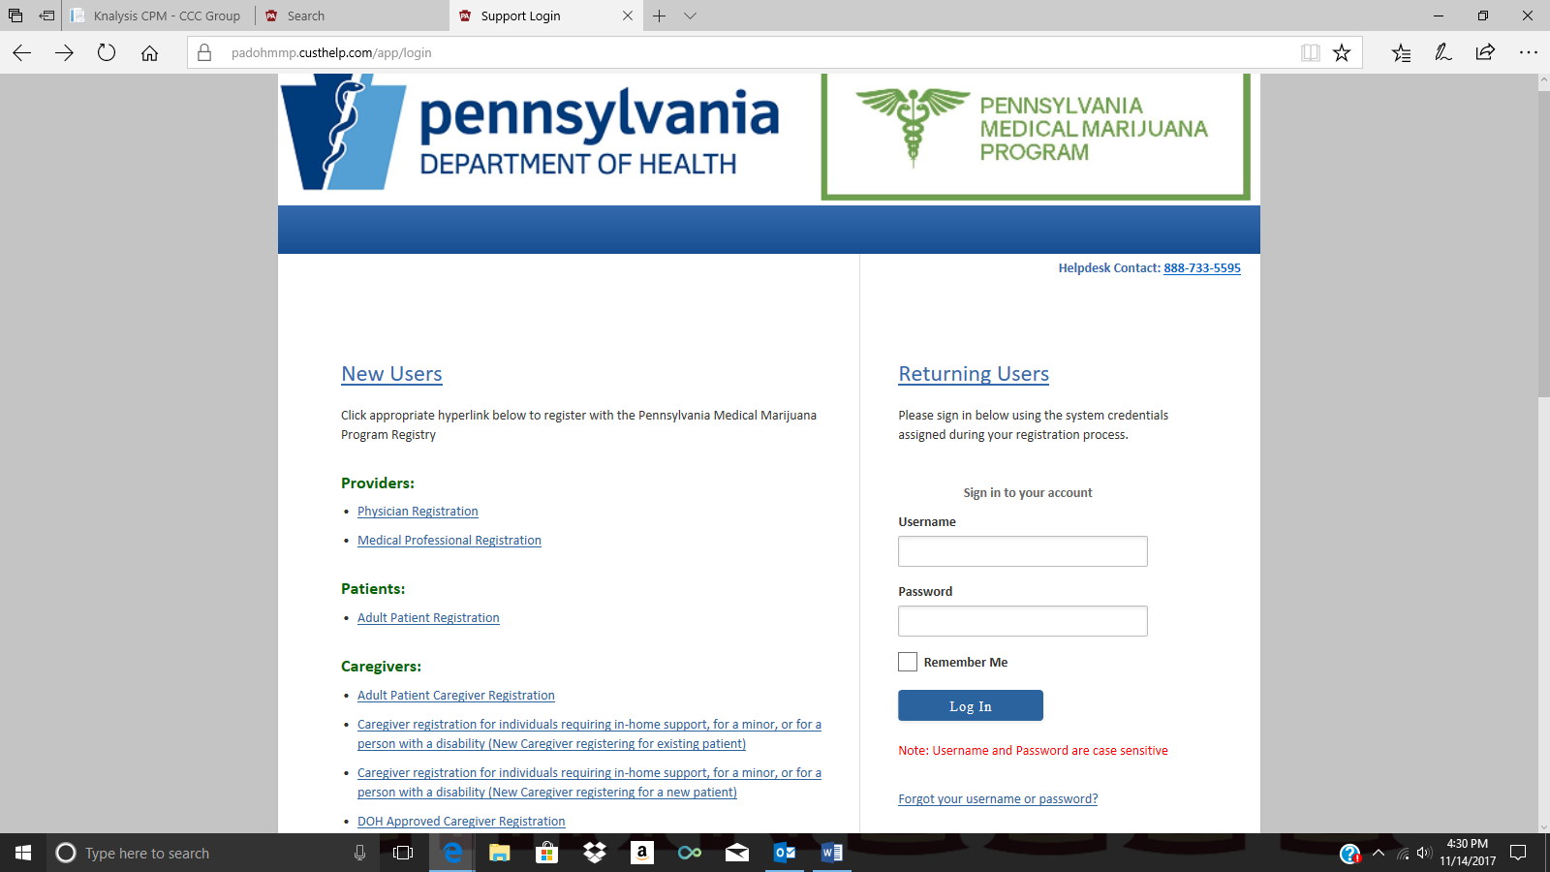
- All information with a Red asterisk next to it must be completed.
- Once that has been completed select “Submit”
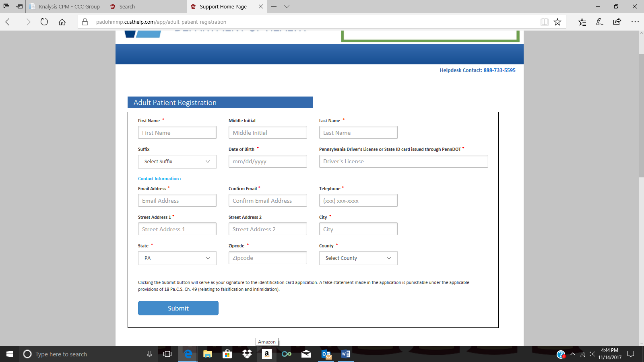

- Consulting with the patient, create them a username and password.
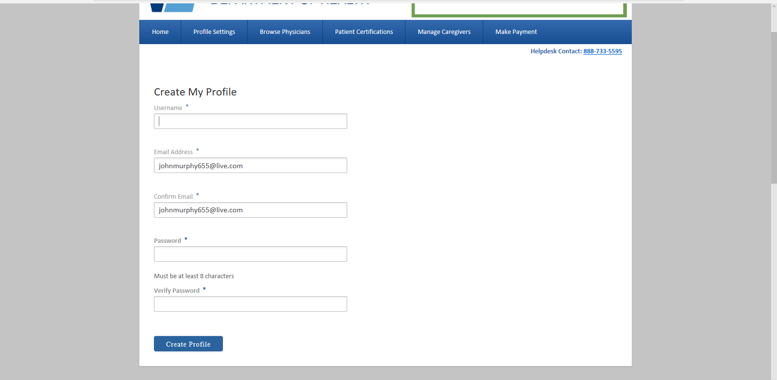
- Profile alterations can be made but are not necessary
- The Patients ID number can be found in the “Profile Settings”
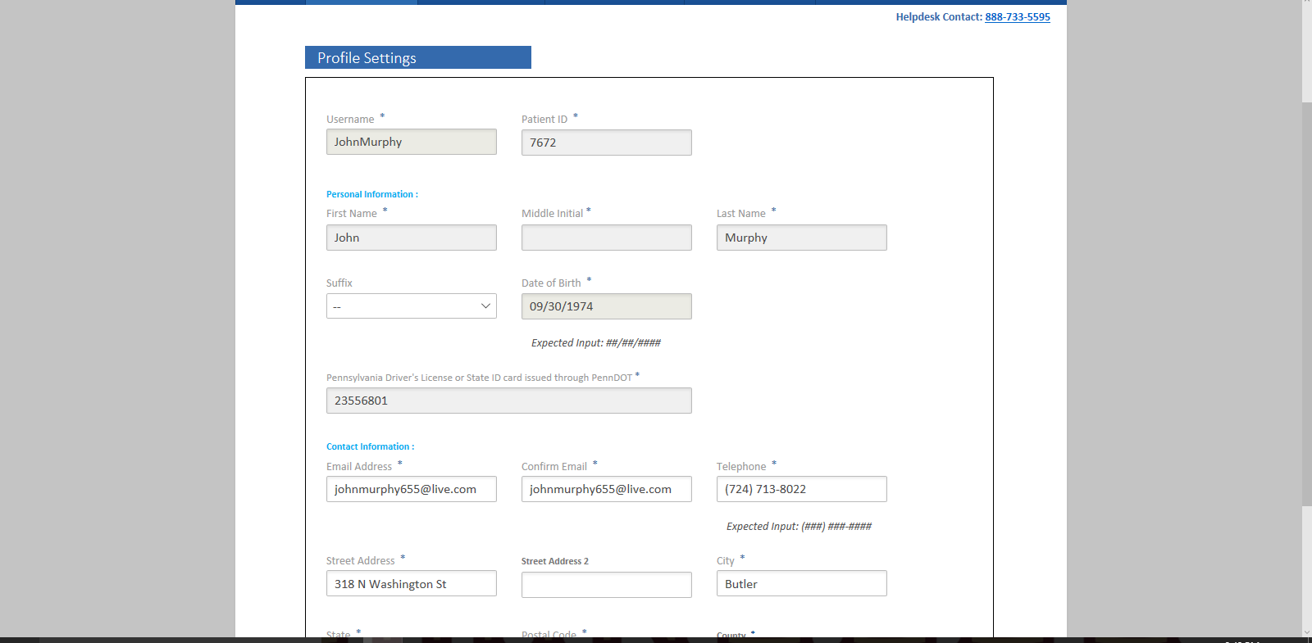

- Select “SUBMIT” The patient has now been registered with the state!
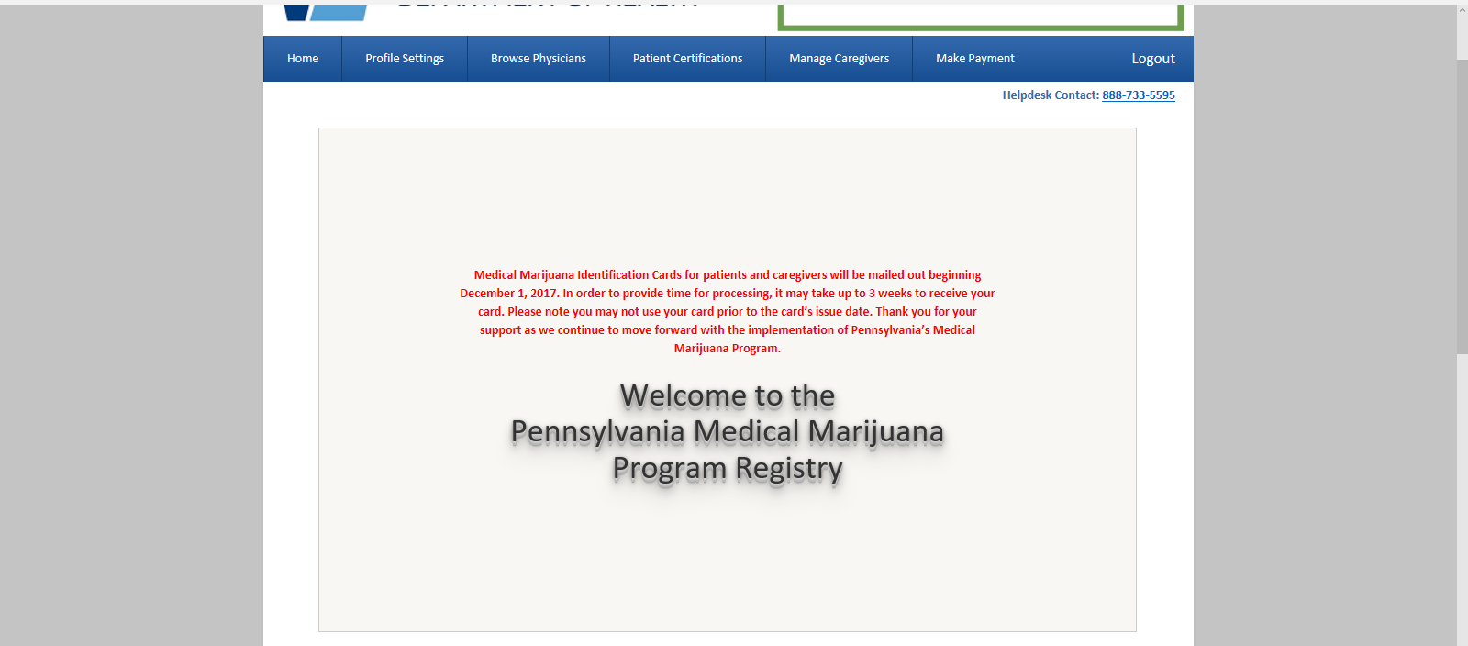
- The status of the patient’s certification can be found in the “Patient Certification” Section.
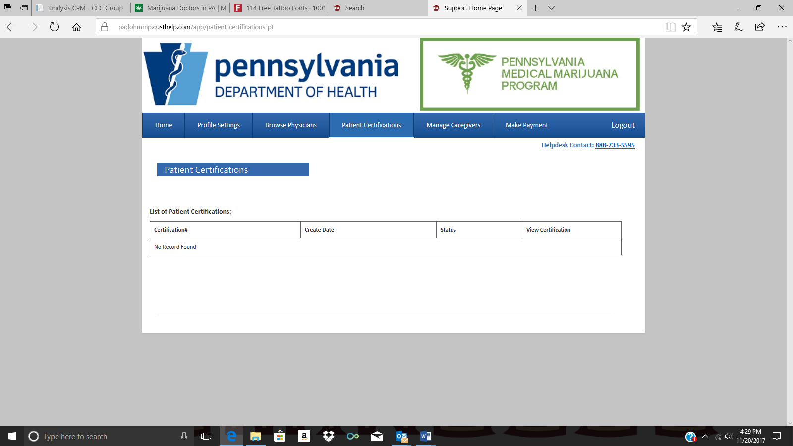
- Caregivers can be altered and added in the “Manage Caregiver” Section
