Knalysis Training
Knalysis (also known as Cannabis Patient Management; CMP) is our scheduling and patient service program. It was created specifically for our needs. In this training packet we are going to go over the basics to help make you successful; we are going to cover logging in, searching for patients, and scheduling appointments. We are also going to go what is needed in each patients account. If at any time you have any questions, please stop your trainer and ask.

Getting to Knalysis: https://ccc-cpm.azurewebsites.net/Account/Login?ReturnUrl=/ (please save this link to your favorites as this is something you will use daily)

It is important to remember to LOG OUT any time you are away from your work station for an extended amount of time. You are responsible for what happens under your username. Do not share your password with anyone and do not allow anyone to work under your name.
Learning the System:
Logging into your account.
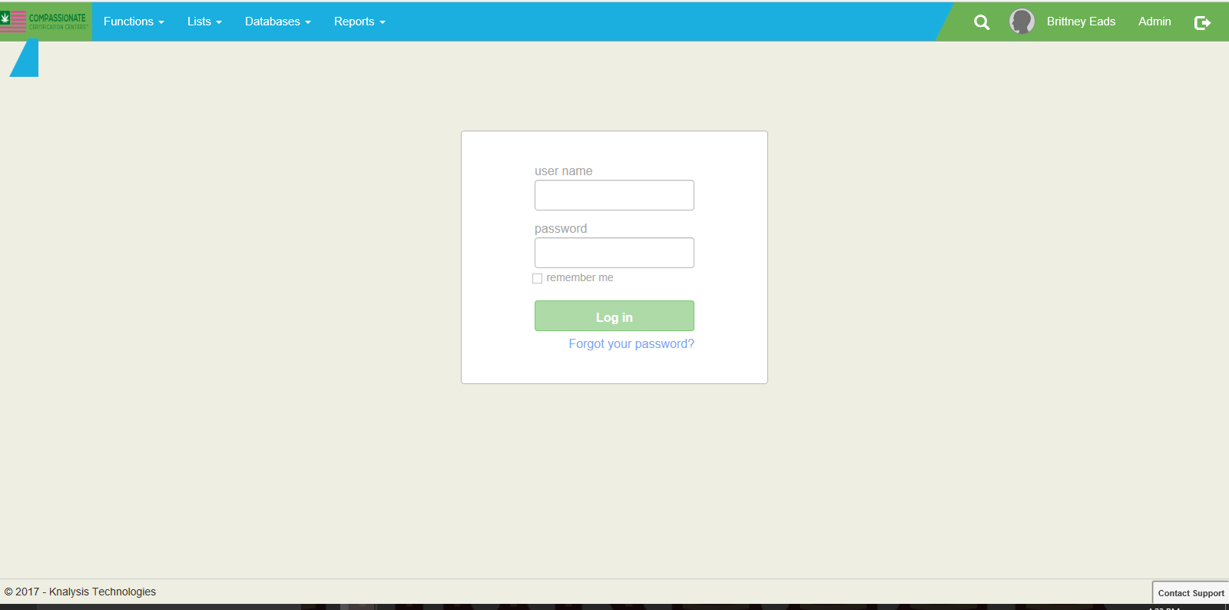
Enter your User name and Pass Word DO NOT SELECT THE “REMEMBER ME” Option.

Searching for Patients.
It is important that we are not creating duplicate accounts (the same patient with multiple accounts). A great way to reduce this risk is by searching for patients more than one way. The Pt’s date of birth (DOB) is the easiest and fastest way to search for an existing patient. It is recommended that you also search by the patients first and last made as well (verify the spelling with the patient). Once you have concluded that the patient is not in our system you can move on to registering the patient.
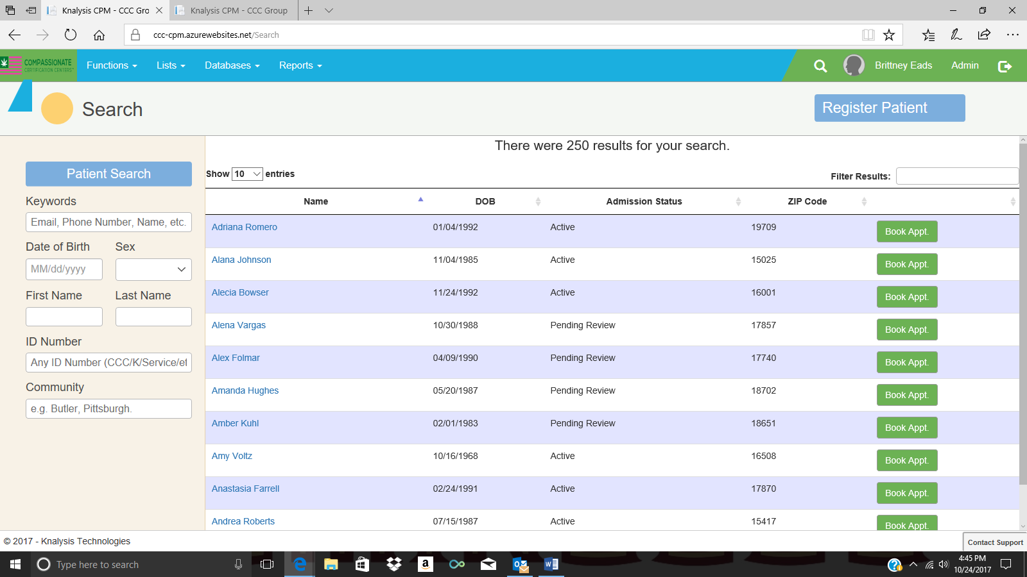
To Register a New Pt.
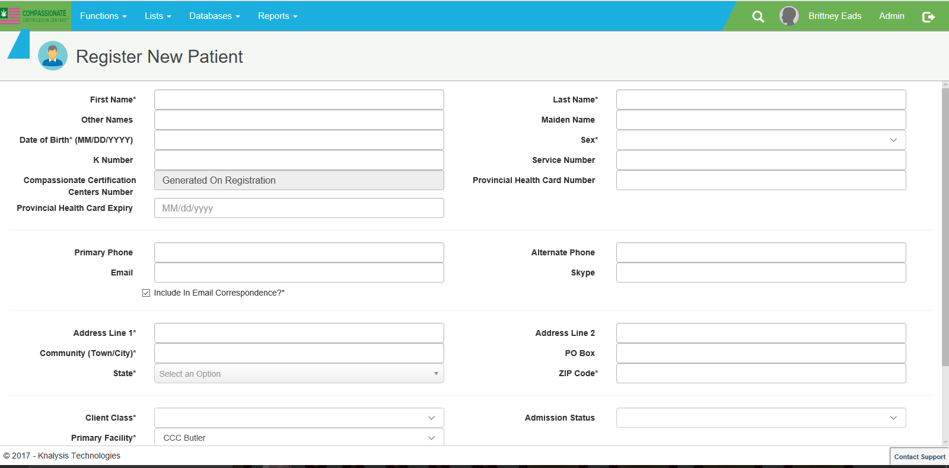
The asterisks (*) indicate this is information that must be filled out before you can move on to the next step. Once all of that is done, then click “SAVE.” The patient has now been created.

Scheduling an Appointment
Once you are in your selected patients account-to your right you will see a green button that says “BOOK APPT”
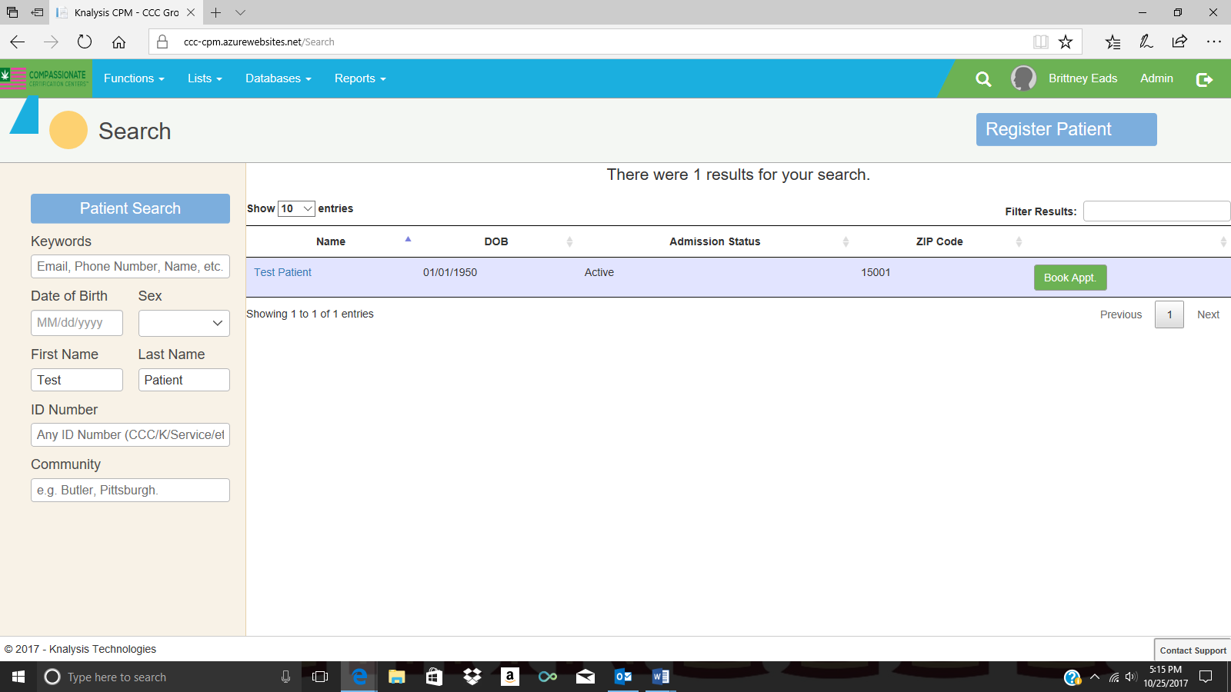
Select “Show Prescriber Availability” (Show CTE Availability is for nurse use).
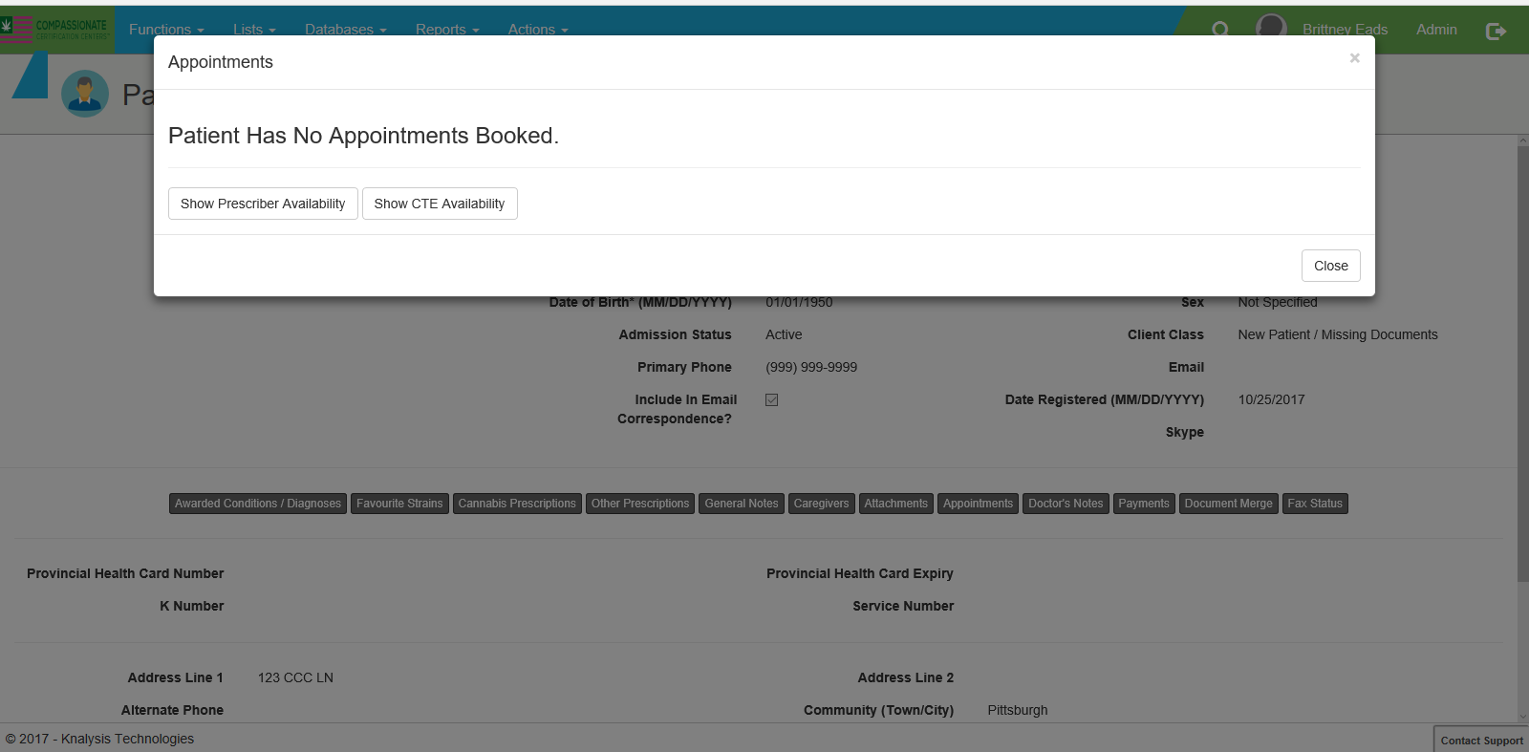
From there you will be provided with our locations and days that are available Select the location, and date you are looking to schedule the patient on.
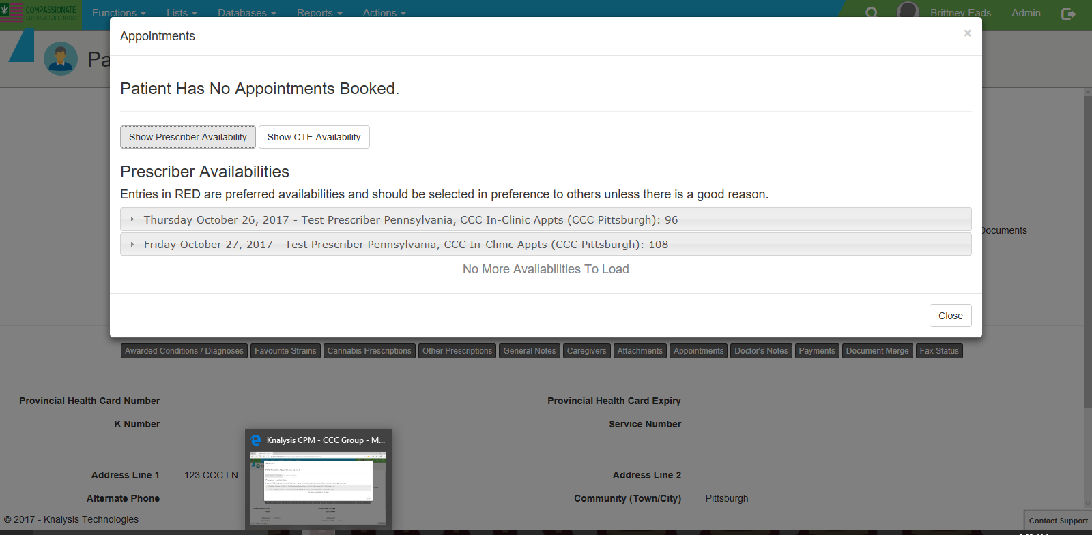
Select the time that is agreed upon with the patient. You will be asked if you are sure you want to select that time; select the YES option.

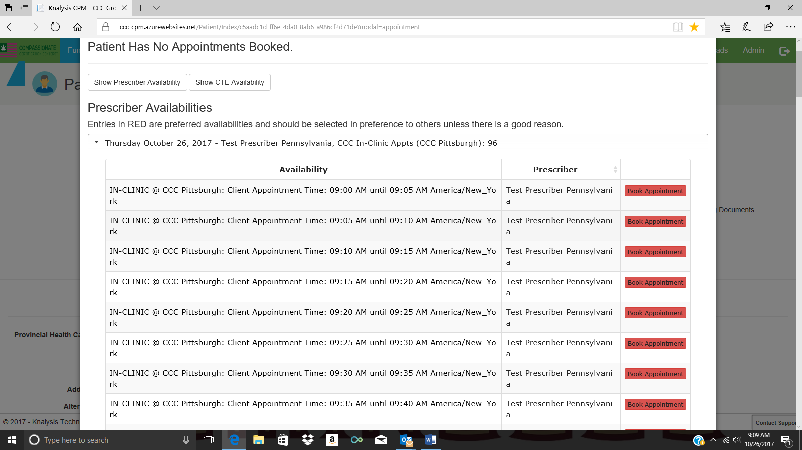
This is the final step in scheduling. Here you will enter any notes pertaining to the apt. You can also add an email address so the PT can receive a confirmation E-mail about the appointment they have set up.
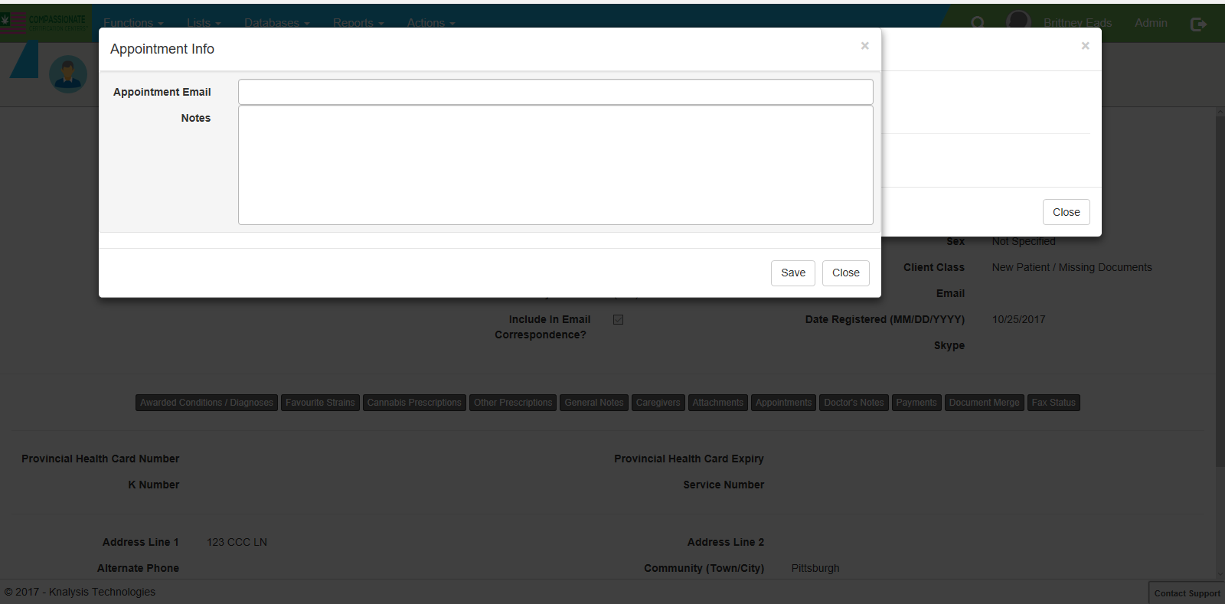

What We Need Before Seeing the Patient
Proof of PA residency:
- PA Driver’s license
- Utility bill with PT name on it (Water bill, Electricity bill)
- If the patient is a minor or is medically dependent on a care giver, please get their information.

Photo ID:
- PA Driver’s License
- Pass Port
- Library Card
- If the patient is a minor or is medically dependent on a care giver please get their identification; while in the office we will obtain a photo of the patient for our records.

Previous Medical Records:
- Any supporting documents the patient has from their physician with a diagnosis on it will help our physicians in their decision making. We should encourage our patients to get their medical records PRIOR to being seen in our office.
- Pennsylvania Department of Health Prescription Drug Monitoring Program (PDMP) Questionnaire

Documentation Needed in Accounts

Anytime you are working one-on-one with a patient you should make notes in their account. This will allow others to know the status of the patient in case you are not available to help the patient. For example: Brittney calls patient Test Patient to schedule her for an APPT; the patient does not answer the phone. Brittney makes notes in the General Notes portion of the patients account “lft msg to schedule for apt.” This will allow for Megan to know what Brittney has done in the account in case Brittney is unavailable to help the patient when they call back.

All notes should go in the General Notes section on the patients account. You can find the General Notes in the main patient screen.

