HIPAA Training
Type HIPAATraining.com. into your web browser
Select the LOG IN feature at the top right.
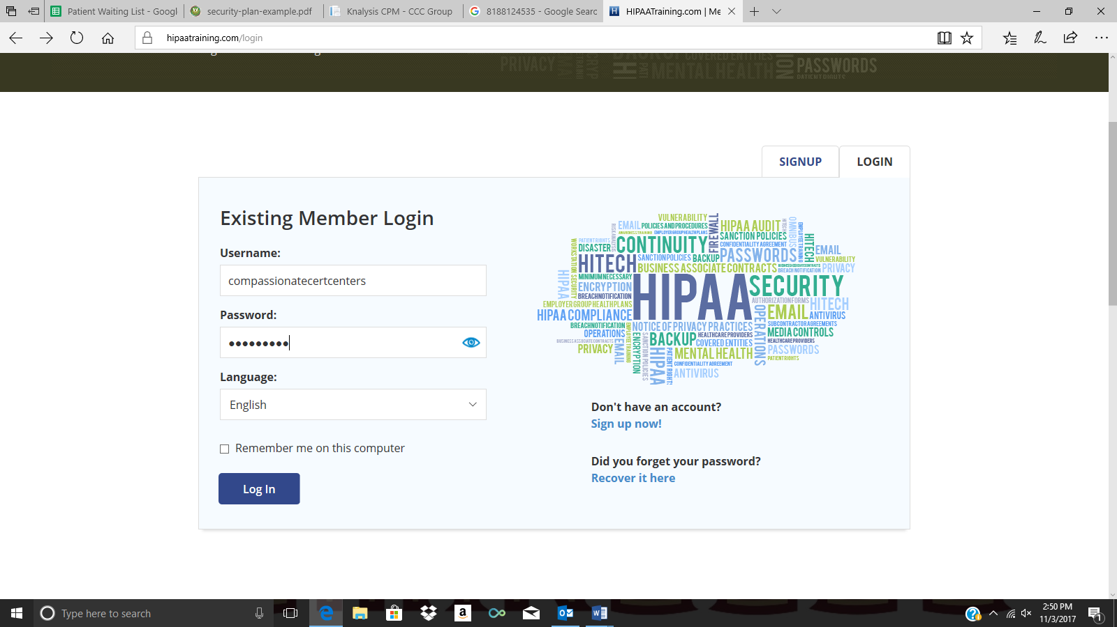
Log in using:
Username: compassionatecertcenters
Pass word: Ccc1234!!

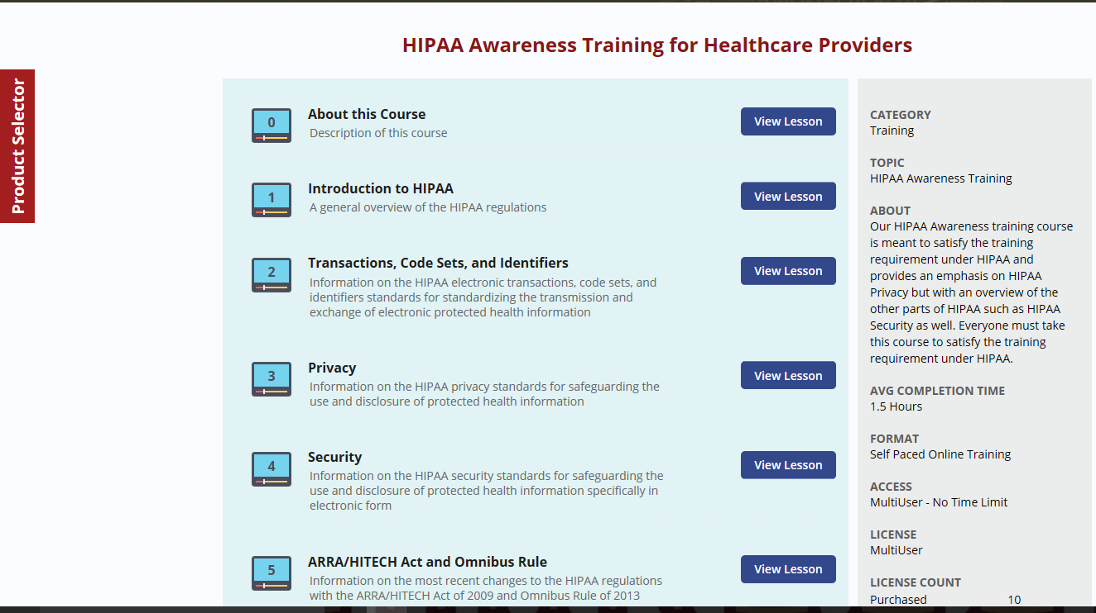
At the end of each lesson it is encouraged that you take the QUIZ. At the end of the final section, 6, you will be prompted to take the “FINAL EXAM”
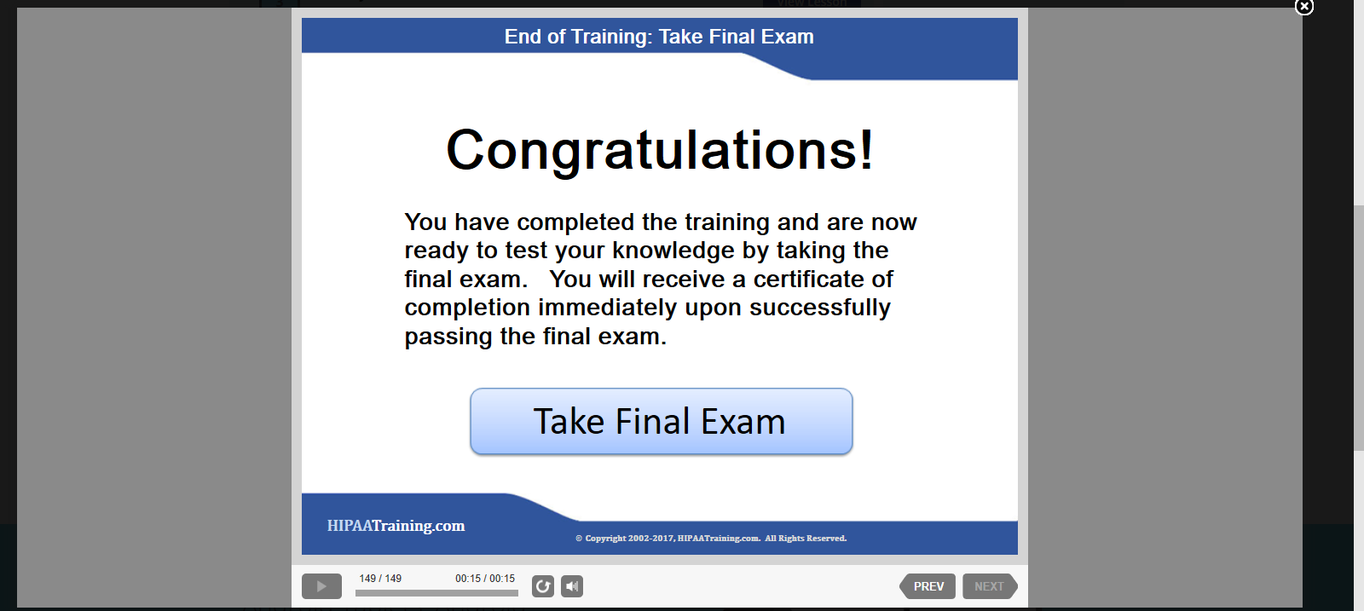

After successfully completing the final exam you will be prompted to provide you name and e-mail address that the certificate can be sent to. Once you receive the email please forward a copy of your certificate to Megan Sumner (megan@compassionatecertificationcenters.com) so it can be added to your employee file.
