Compassionate Certification Centers
CPM Training

What we do:
- Schedule patients (usually this is done before they come in because they have called out 888 number)
- Scan/upload medical records (an attempt has been made to pre-collect these documents at scheduling).
- Collect payments for office visits and CBD purchases (while scheduling an attempt has been mad to collect the office visit fee).
- Have all necessary documents signed by patients (if the patients have pre-registered online the forms were electronically signed, if they did not they need to be signed in office, the forms can be found in our company portal).

Office Equipment used:
- Stationary desk top computer or portable lap top computer (to be determined)
- Printer
- Scanner (for uploading records that have been brought into the office)
- Square reader cards (used for collecting office visit fees on site, collecting payments for CBD purchases)
- Our prices are listed on our website but in case you are asked:

$199 Medical Marijuana Card Visit (we accept all major credit cards or cash)
$75 Physician Medical CBD Consultation
$50 Registered Nurse Consultations CBD
$75 Follow up in person visits if requested
$125 Yearly renewal fee for the card

What you won’t find in our facilities:
- Patient charts (everything we do is virtual (online), it is all backed up daily on the cloud network and our EMR system)

Before patients have been added to our schedule they have been asked to go to our website (https://www.compassionatecertificationcenters.com/) and pre-register. Here the patients enter their information and are asked to upload their photo ID and medical records, medication records, they are able to select their diagnosis and have electronically consent forms.

Each night before leaving the office manager will export the next day’s schedule and send to themselves via email. When they arrive to the center in the morning they will print that schedule, so it will be available in case the website goes down. It will look similar to this:

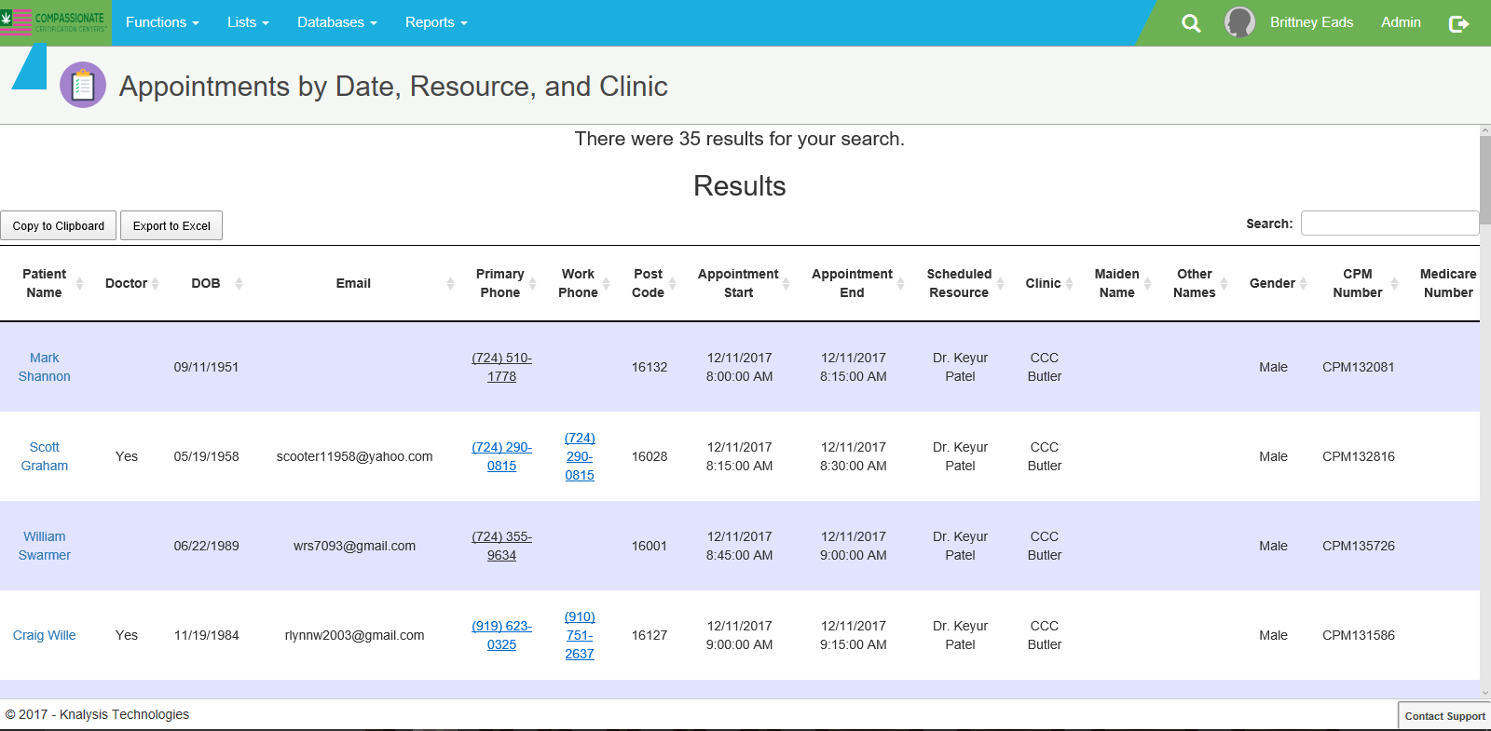

Using our CPM Program:
Cannabis patient management (CPM) is our scheduling and patient service program. It was created specifically for our needs. In this training packet we are going to go over the basics to help make you successful; we are also going to cover many different topics that you are going to use daily. If at any time you have any questions, please stop your trainer and ask.
Getting to our CPM program:
Knalysis: https://ccc-cpm.azurewebsites.net/Account/Login?ReturnUrl=/ (please save this link to your favorites as this is something you will use daily)
Learning the System:
Logging into your account.
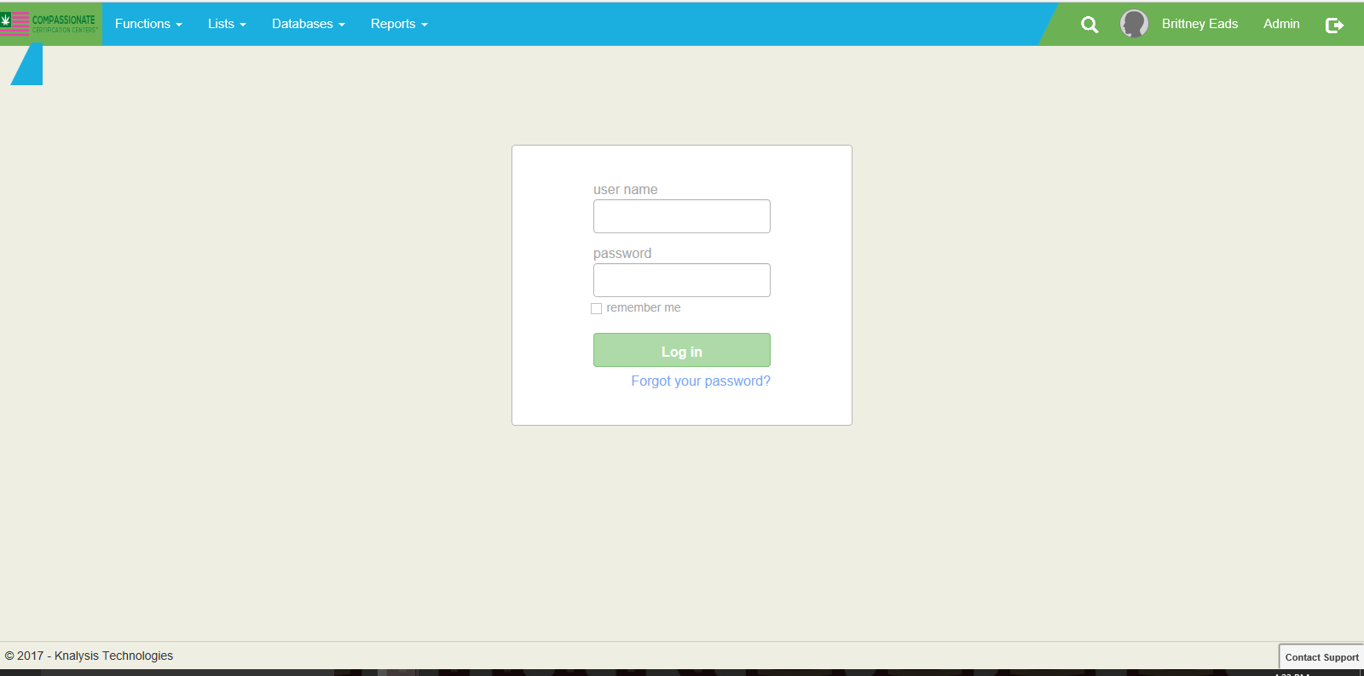
- Do not select the remember me option
- Log out when you are done/don’t let anyone work under your name
- Do not share your pass word with anyone
Once logged in you will be brought to the mail Dash board:
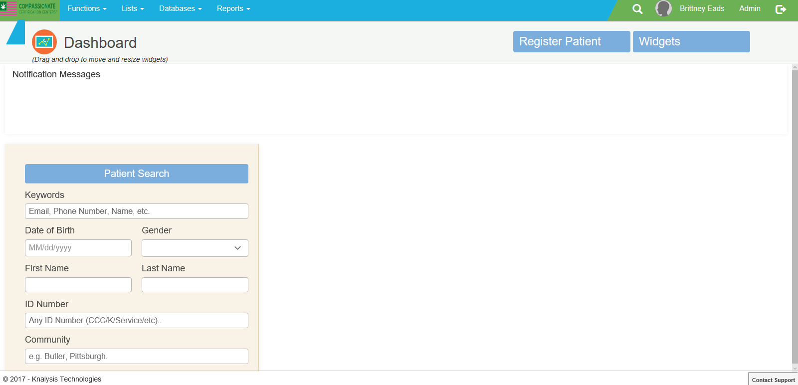

To see your patients scheduled for that day you will select the FUNCTIONS drop down box; select CALENDAR
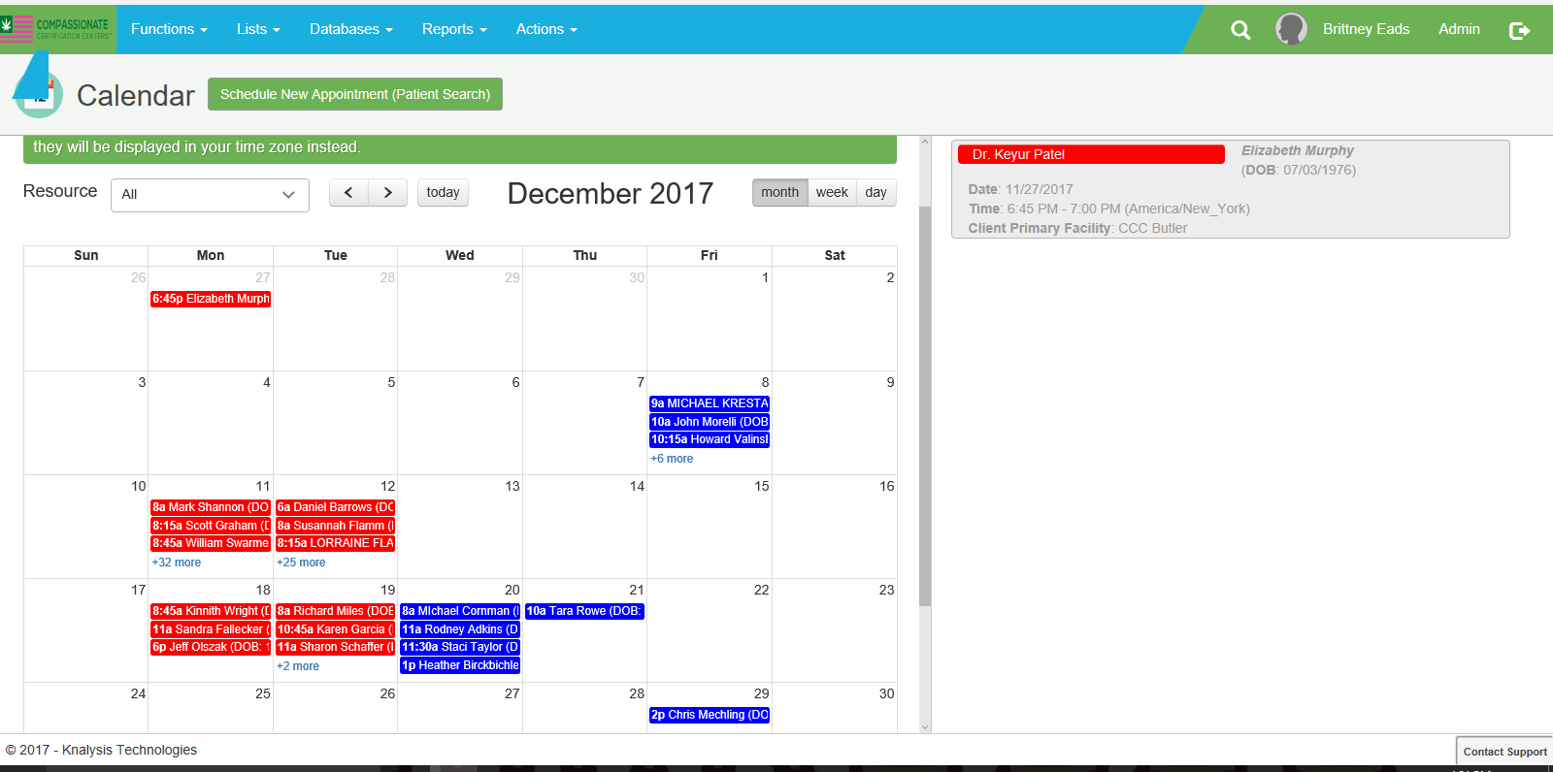
- Each day of the month’s patients will be shown
- Put your curser over the patient you want to see; double click
- You will be brought into their account allowing you to edit their S.O.A.P. Notes.

How to collect a payment:
- A square card reader will be located at the front desk and the software will be on the computer
- Enter the amount you are collecting in the appropriate box
- Slide the card the card through the card reader; select submit.
- Print 2 receipts; one for the patient to sign (our record) and one to give to them.

How to know if a patient has paid/how to post a payment:

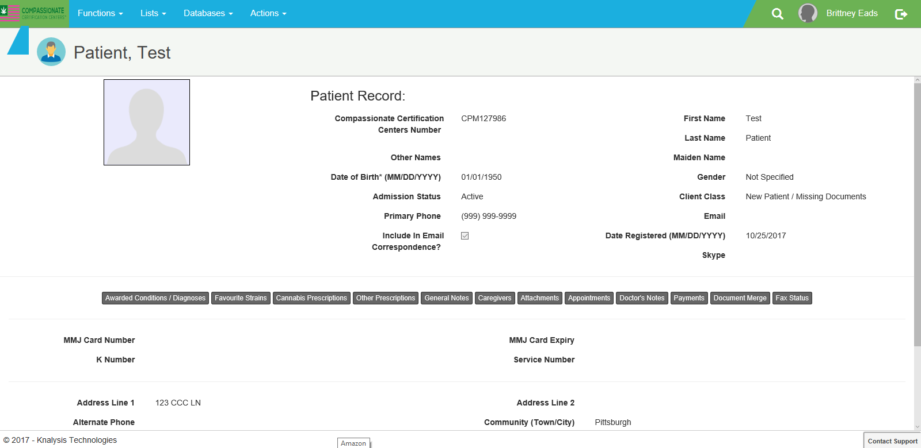

- Go into patients main account
- Select the payments tab
- If they have made a payment it will be collected here.

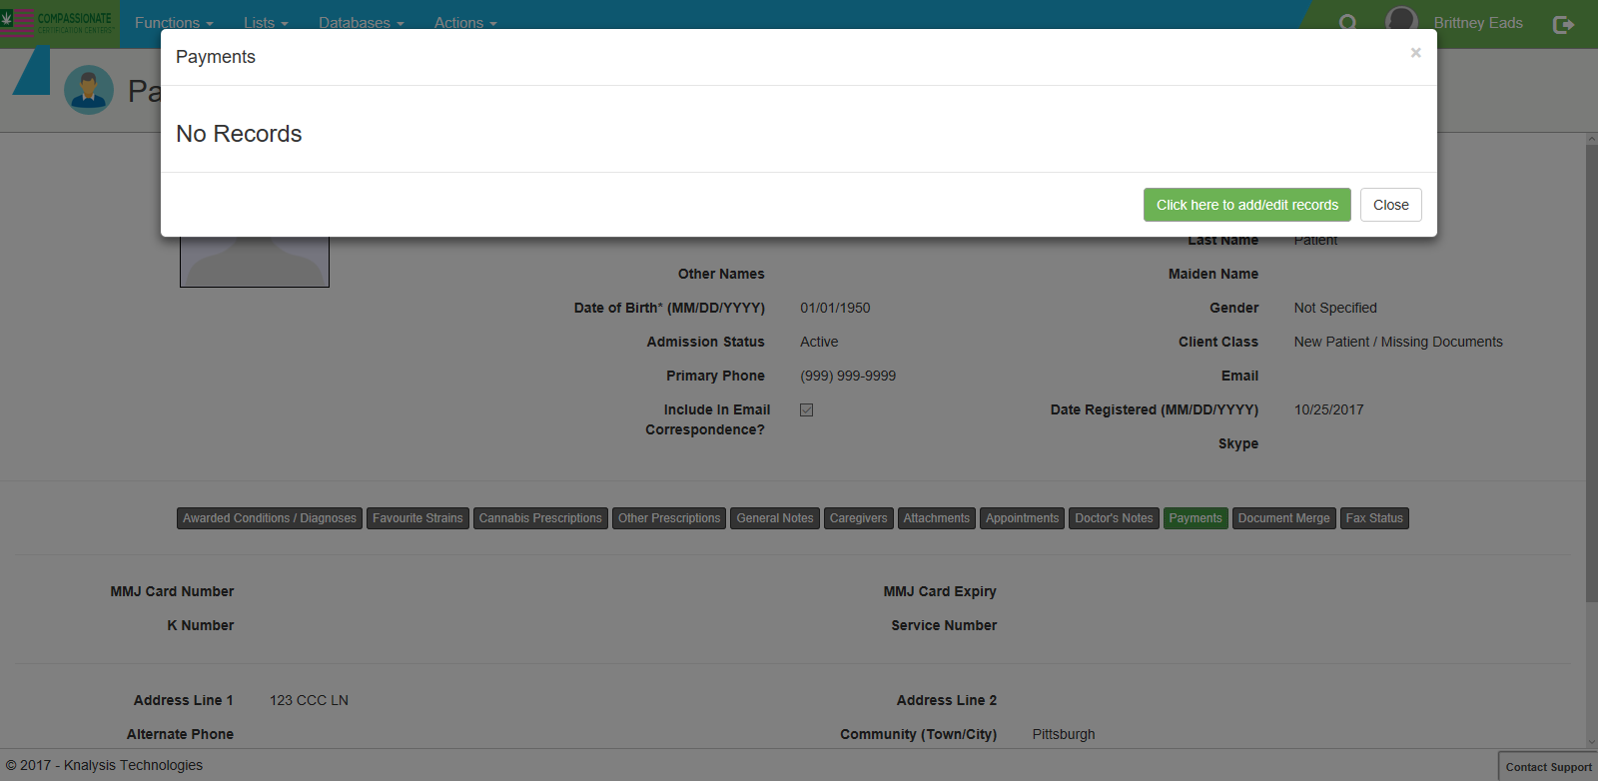

- If the patient is paying in office, select the GREEN option to add a record.

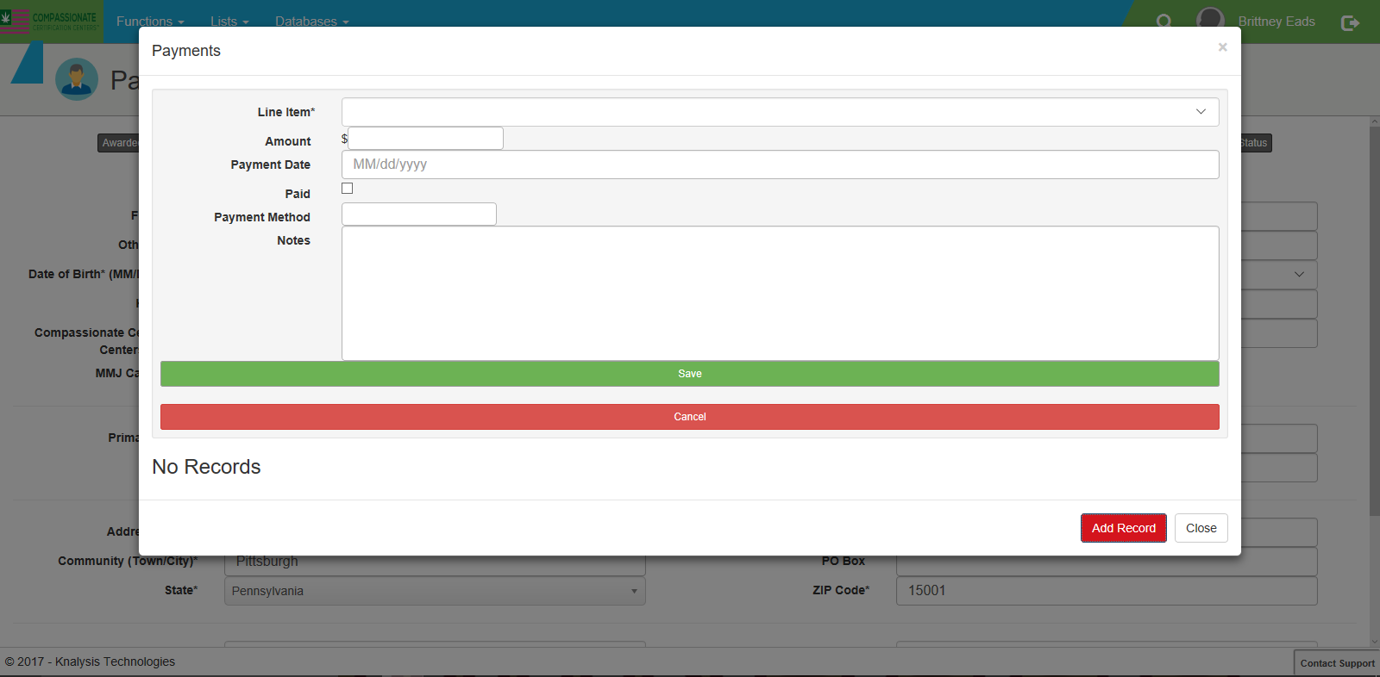

- Line item indicates why: new visit, follow up, CBD purchase etc
- Amount- how much the paid
- The date the payment was collected
- Check the PAID box
- Payment method- Cash, check, card
- Notes-if we collected any amount other than the standard amount EX “Per Dr _____ only collect $150 for today’s visit.
- Select “SAVE”

To Register a New Pt.:
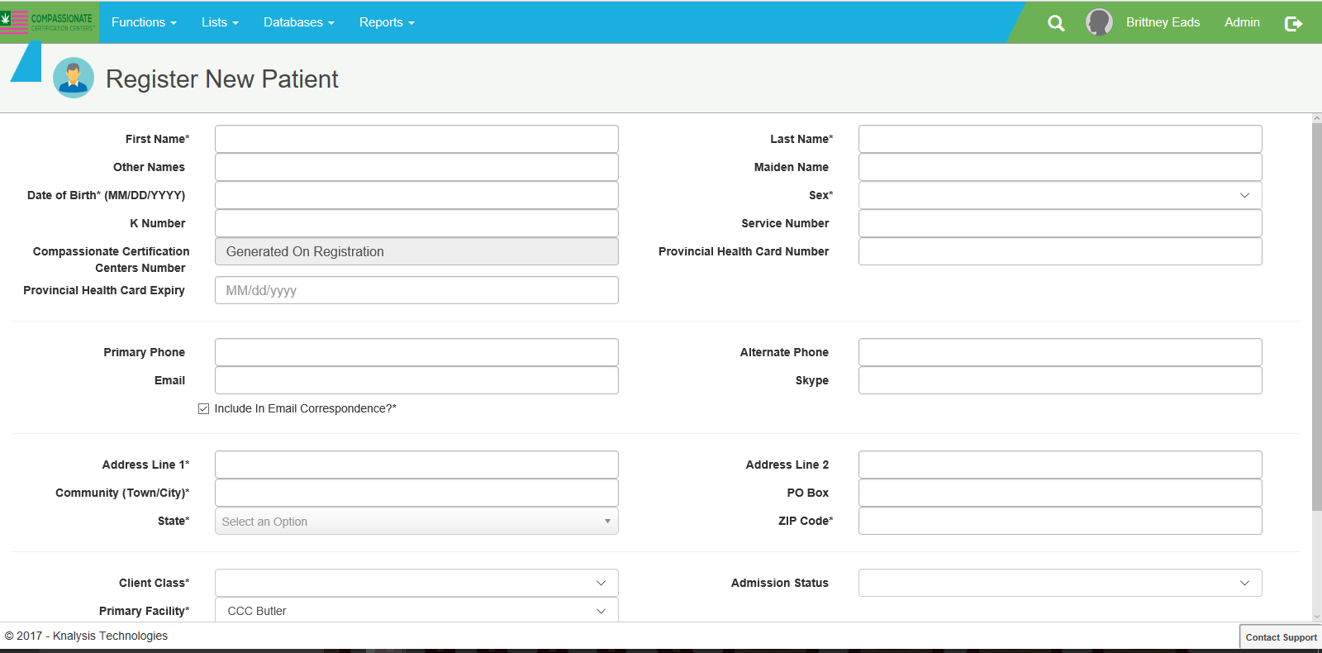
- The asterisks (*) indicate this is information that must be filled out before you can move on to the next step.
- Once all of that is done, then click “SAVE.” The patient has now been created.

CBD Products:
- We offer several different types of CBD products. Full details on each Item can be found in our portal.
- CBD types offered are capsules, chews, drops, gummies, liquids, tinctures, cream, salve, balms, and CBD for pets
- Patients can order these products online or purchase them at the facility if the facility has them in stock.

What patients take with them:
- After their visit the patients will be given a white folder for handouts and information regarding our company. These documents can also be found in our company portal.
- CBD Recommended Guidelines/Dosing
- Knalysis tracking app
- Safe Medical Marijuana Use
- Who we are brochure
- Follow up appointment card (if needed)

Media Guidelines:
Proven Media is the agency we use, if you are ever asked for an interview or a statement please refer to them:

Kim Prince
President at Proven Media
Kim@provenmediaservices.com
480-221-7995

Neko Catanzaro
Vice President at Proven Media
Neko@provenmediaservices.com
401-484-4980
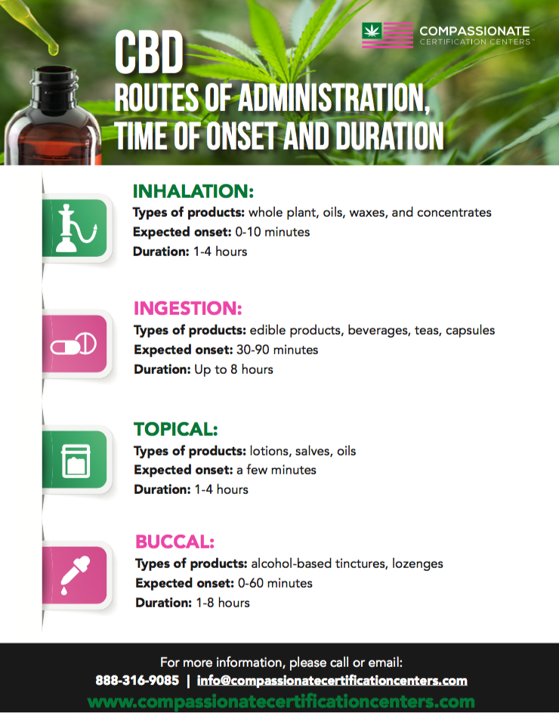

Department of Health
Prescription Drug Monitoring Program (PDMP) User Guide
(Please note that all patient identification information has been removed to protect the privacy of the patient being used in this demonstration.)

This step ideally needs to be done PRIOR to the patient being seen in the office, if possible. Alternatively, it may be done at the office by the evaluating physician during the patient appointment. If at any time the website is not available, it should be checked as soon as it does become available. At the end of this training guide you will find instructions on what to do if the website is not available. Please note, it is MANDATED by the state of PA that the PDMP is checked on ALL patients receiving their medical marijuana certification.
Once on the website: https://pennsylvania.pmpaware.net/login if you have been assigned as a physician delegate for the PDMP, you will be able to log in with the username and pass word that have been provided to you.

At the top of the screen click on “RX SEARCH”

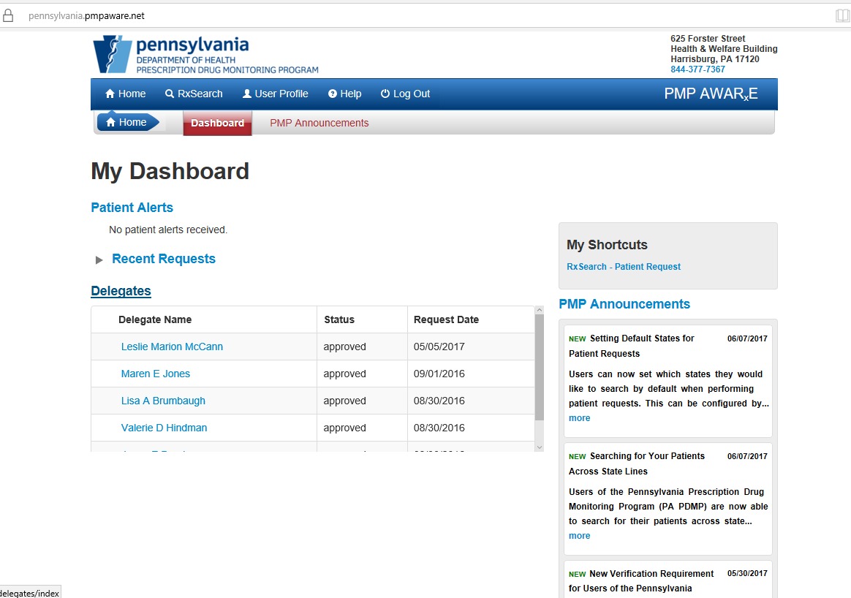

Then select “PATIENT REQUEST”

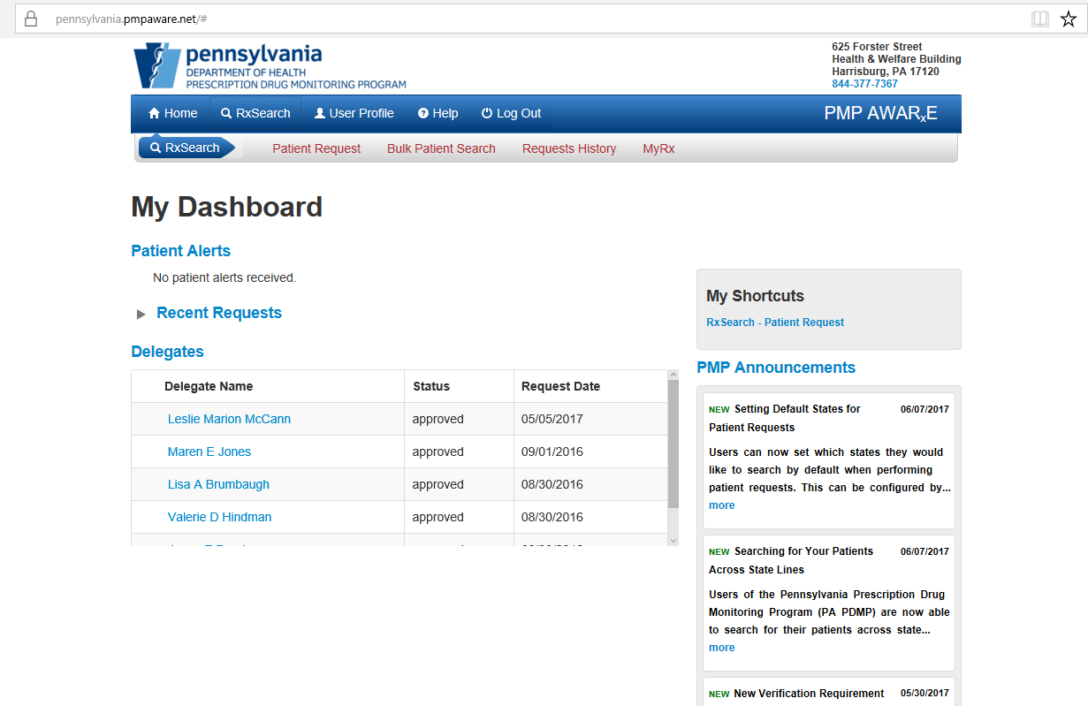

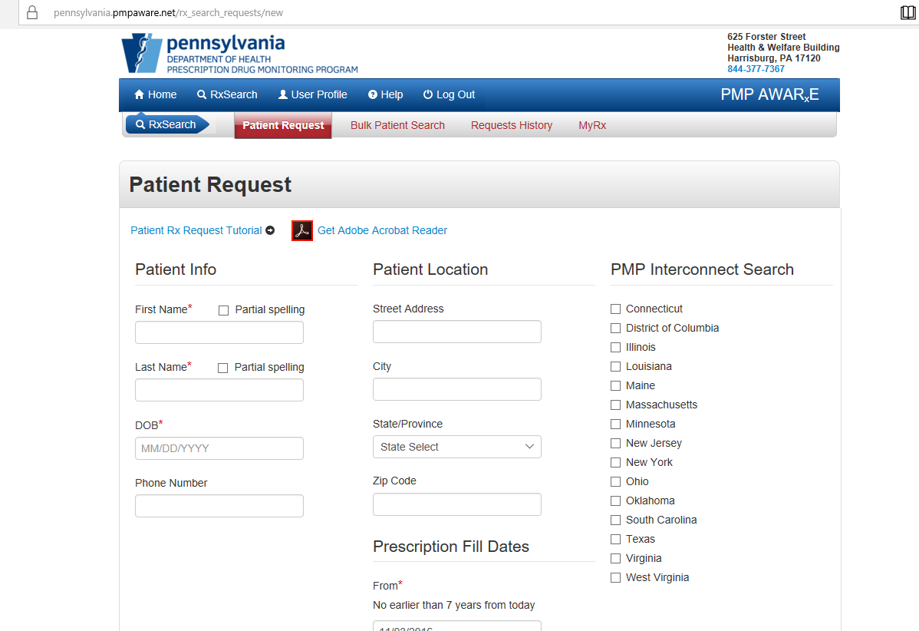

After filling out all required information indicated by the asterisk (*) at the bottom of the page on the right-hand side you will see “SEARCH"

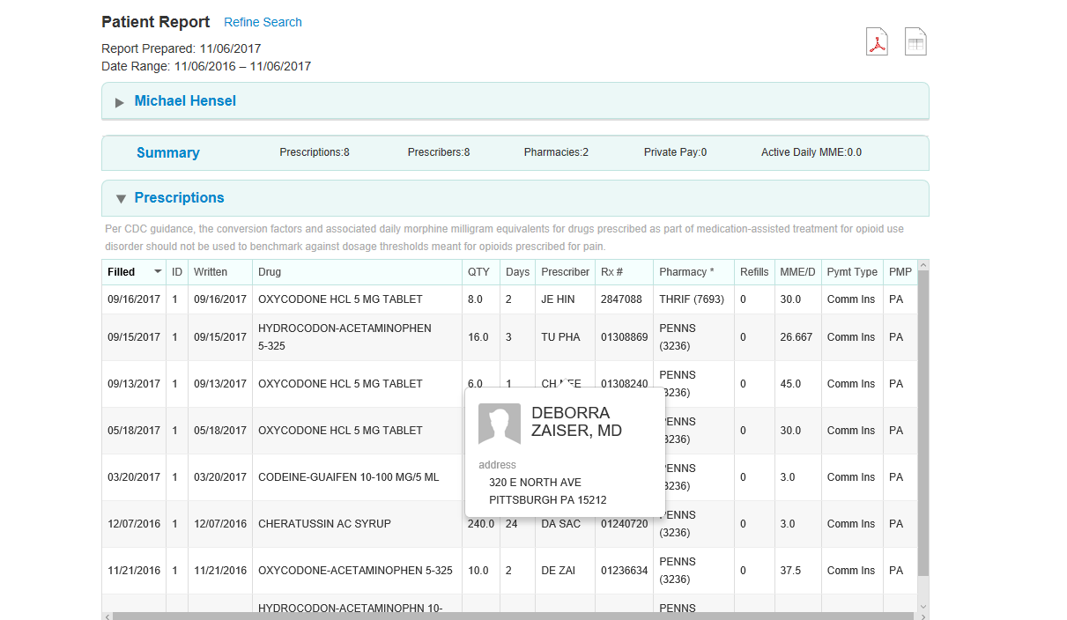

Once selecting “SEARCH” a record of the patient’s prescription list will come up. At the top of the screen on the right you will see two Icons. You want to select the Adobe icon.

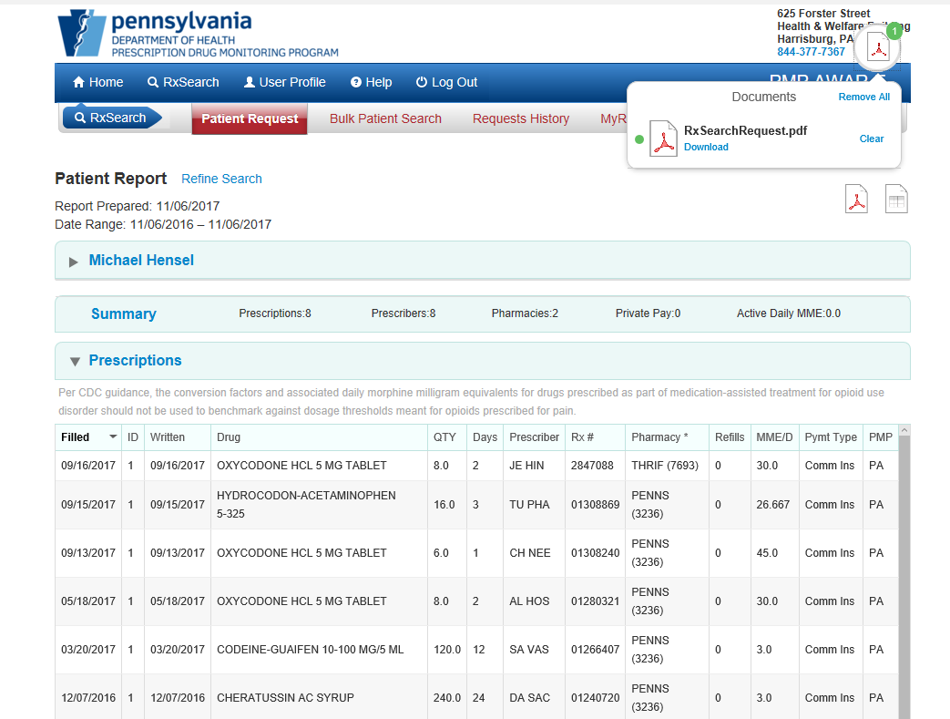

At the top of the screen toward the right a selection box will appear. Select the “DOWNLOAD” option.

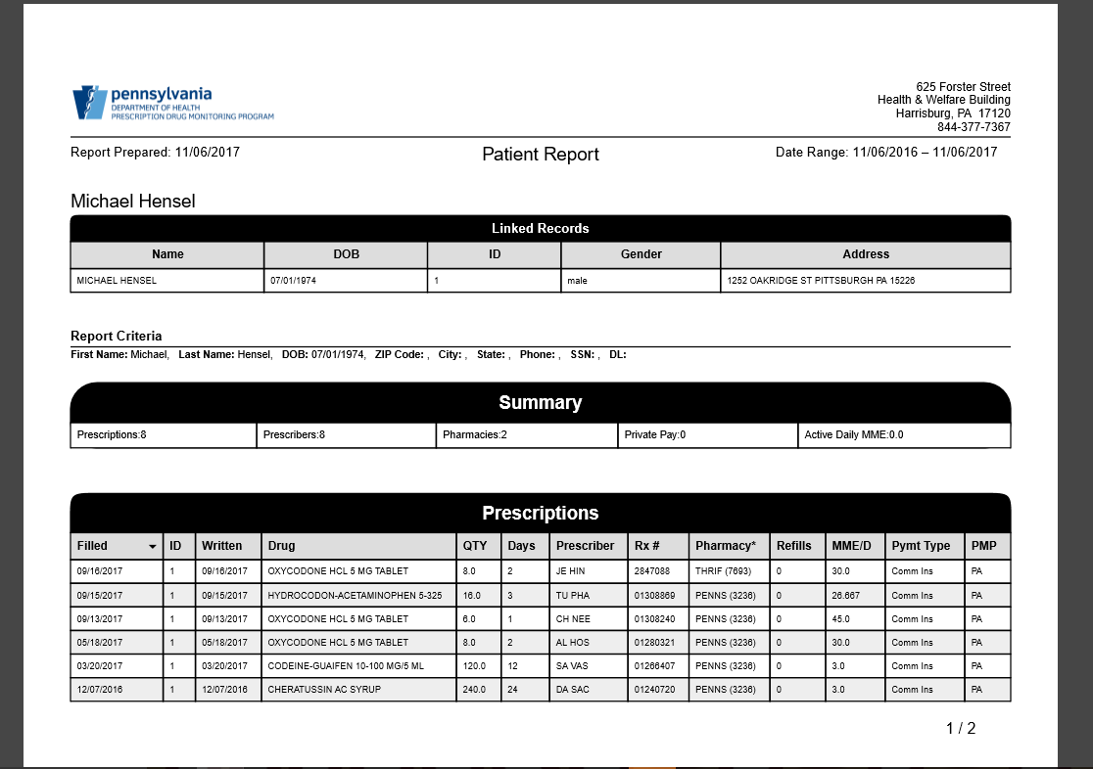

A separate page will open in your browser; this is a summary report, right click and select the “SAVE AS” option. Title the document as the patients first and last name along with the date the report was generated EXAMPLE: PDMP GUIDE 11/06/17 “SAVE”
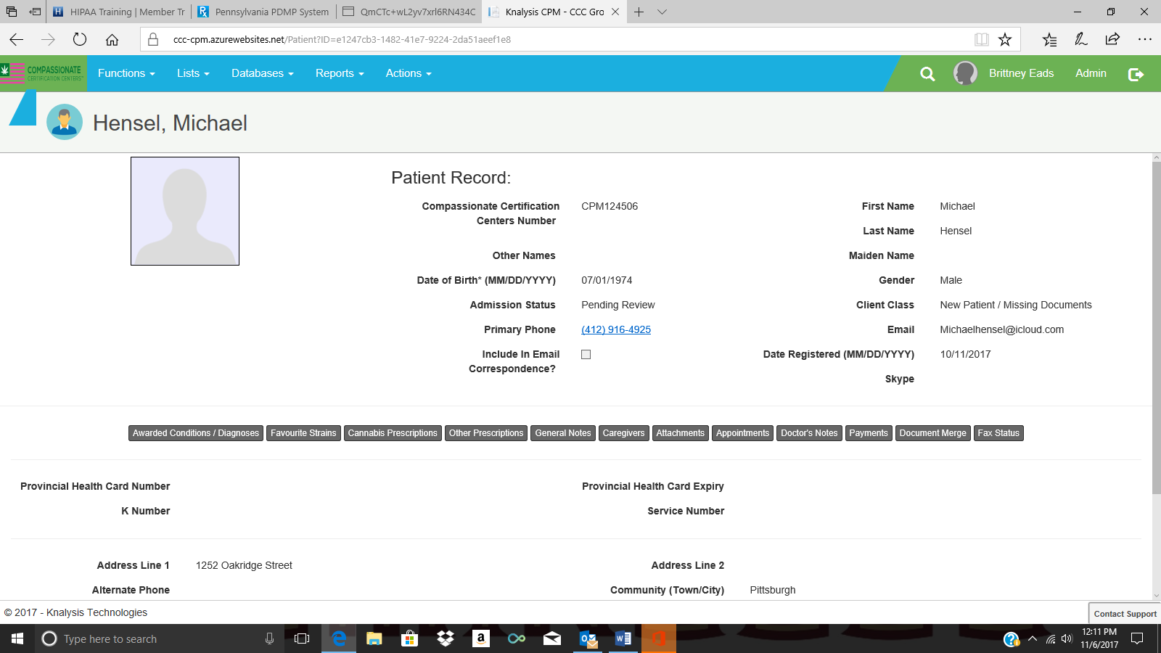

Once the Adobe document has been saved you will want to go into the patients account in Knalysis, the select the ATTACHMENT tab.

A box will appear with the option to “ADD RECORD”
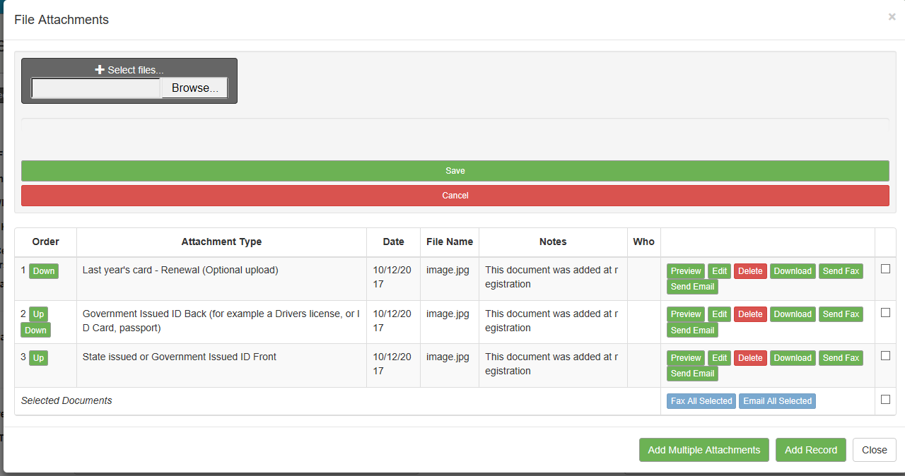

Select the “BROWSE” option.

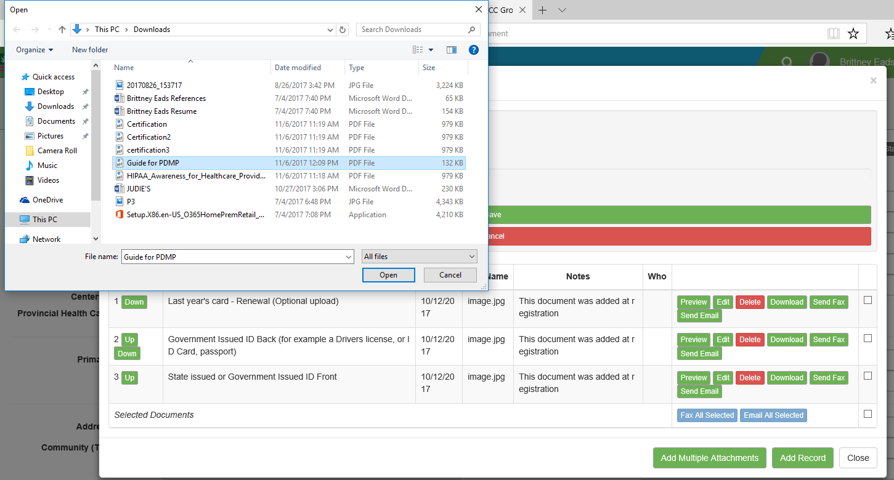

Select the Name of the file you want to up load; in this case it would be GUIDE PDMP, then select “OPEN”

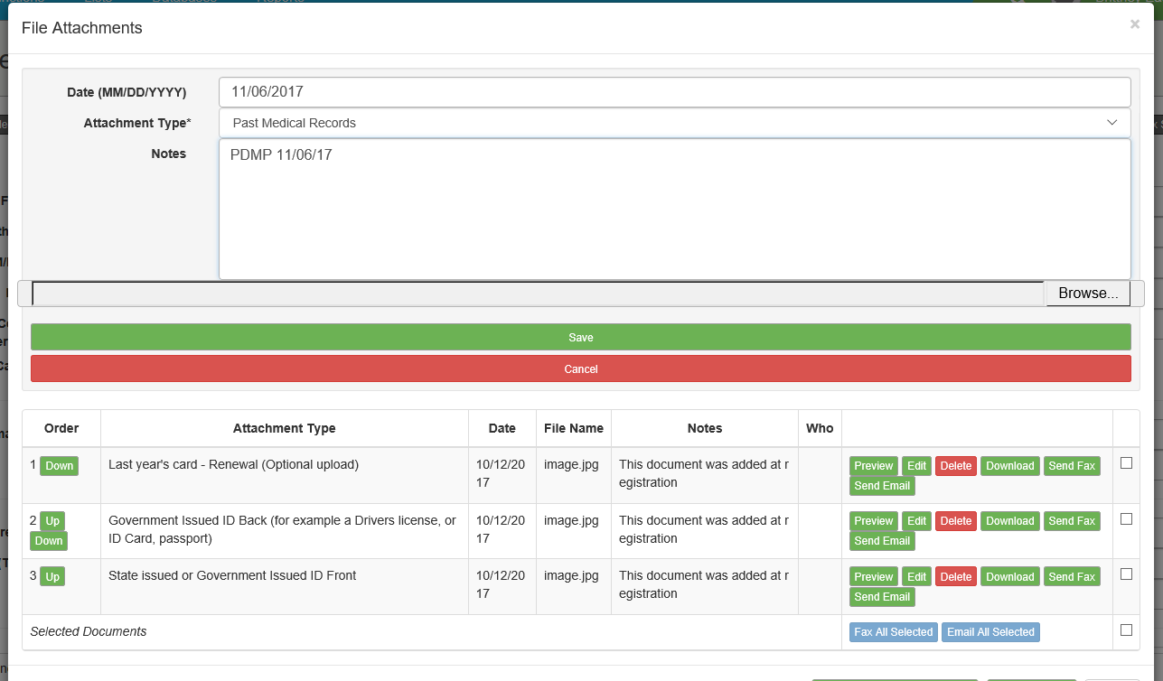

The attachment type should be PAST MEDICAL RECORDS” and the Notes should indicate PDMP with the date you pulled the record; in this case it would be “PDMP 11/06/17.” Once all notes have been entered select “SAVE”

You can select the “CLOSE” option. The record has now been uploaded into the patient’s account for the physician to review.

What to do if the Website is down:
You will need to make a note in the patients account as to why this step was not done before the patient was seen EX: “PDMP website down will verify once it is back up” You can keep track of these patients by making a mark on the report that is generated daily for the patients being seen each day. If the website is not back up by the end of the night you need to secure the list where the next day’s schedule is stored.

Compassionate Certification Centers
Company Portal Training

- Use web link https://www.compassionatecertificationcenters.com/ to get to our website.
- Click the company selection
- The last option will say company portal; click that

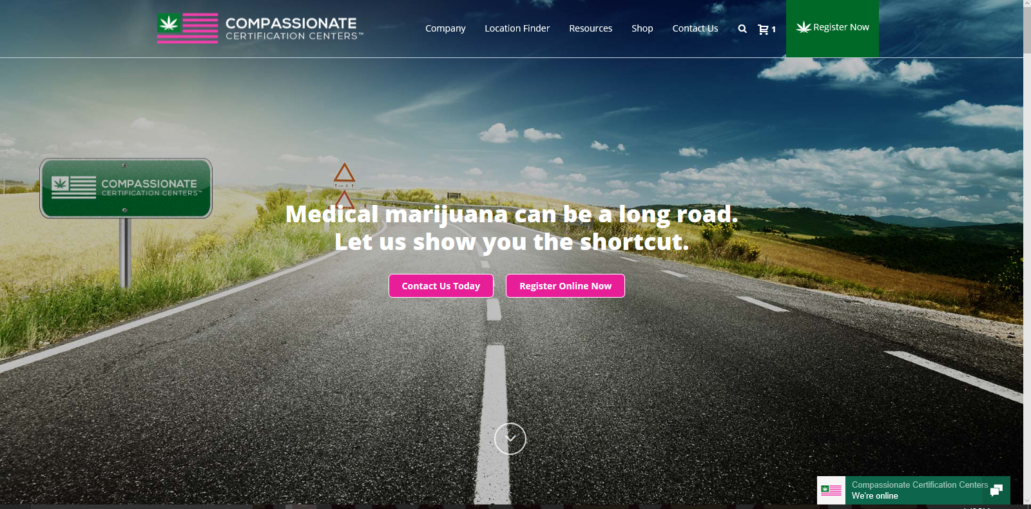

- Enter the Username and Password that was provided to you; select “LOG IN”

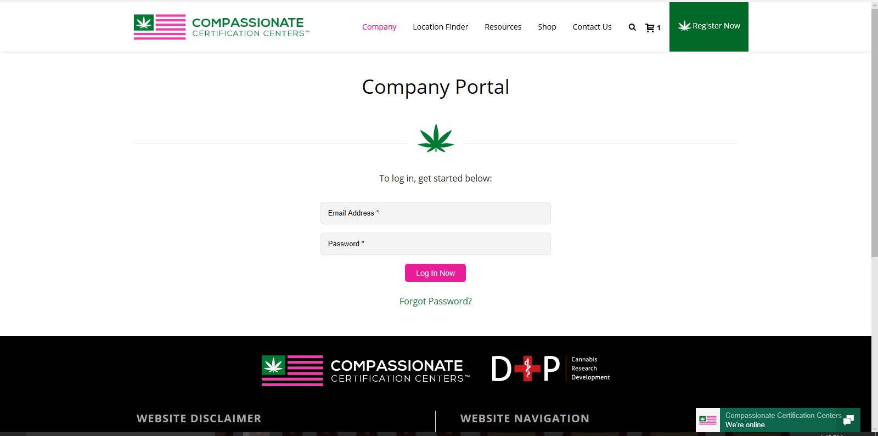

One you are in the company portal to your right you will see search categories.

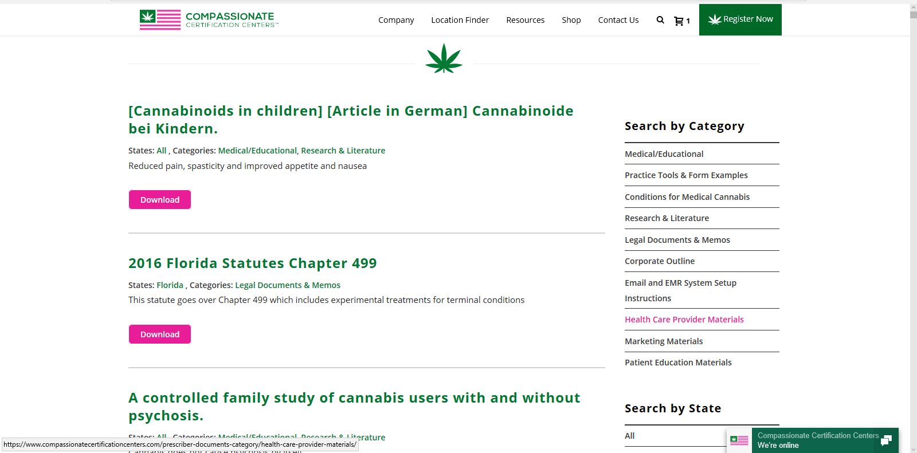

Use the sub categories locate necessary documents.

- Medical Education
- Articles that are relevant to our business industry
- Practice tools
- Information on other states and they marijuana regulations
- Conditions for Medical Marijuana
- Provides information on medical cannabis and the approved diagnoses
- Research and Literature
- Articles on cannabis and the effects it can have with patients
- Legal Documents and Memos
- All memos published by the company; legal regulations for medical marijuana in other states
- Corporate Outline
- Information on CCC, who is who of the company, guidelines, trainings
- E-mail and EMR Set up Instructions
- Detailed Training guides for E-mail, EMR system, and other Trainings
- Health Care Provider Materials
- HIPAA Releases, new physician documents
- Marketing Materials
- Social media handouts, brochures, fliers
- Patient Education
- Patient handouts-Knalysis app CBD recommended dosages

Under that there is a list of all states, that also contains information pertinent to each state and their Medical Cannabis laws.

