CCC Corporate Help Guidelines Handout

Contents:

Page 2 – Email Information and Signature Line Example
Page 3 – General company email addresses
Pages 4, 5 – How to login to our company portal
Page 6 – How to utilize our website information
Page 7 – Knalysis CCC App Information
Page 8 – CBD Store Information
Page 9 – CBD Information Materials
Page 10 – CCC Company Organizational Chart
Page 11 – CCC Company Contact List
Page 12 – Patient Handout Paperwork

Company Email Address Information:

We use Bluehost.com as our email address provider. There are instructions in the employee portal on how to set up your company email address depending on which software you are using (iPhone, Android, Windows, Outlook.. etc)
If you have any questions regarding your email address and set up please contact Megan Sumner.

Signature Line Example:

(Insert first, last name)
(Insert title)
www.compassionatecertificationcenters.com
888-316-9085 (O)
(Insert your company email address)
We are hosting:
2018 World Medical Cannabis Conference & Expo
April 12-14, 2018 | David L. Lawrence Convention Center | Pittsburgh, PA
www.cccregister.com
#MEDCANNCONEX

https://www.youtube.com/watch?v=f5cImJiORnI

General Company Email Addresses:

Questions@compassionatecertificationcenters.com - This email will be included on the company business cards that are handed out to patients so that they can email any questions they may think of after they leave the appointment. Megan and Brittney will manage and delegate questions to the appropriate staff member(s).

Intake@compassionatecertificationcenters.com - This email is used for patients and other physician offices to email patient records, photo ID, etc.. to be uploaded into the patient portal in the CPM (cannabis patient manager).

Orders@compassionatecertificationcenters.com - This email is set up with our online CBD shop. When a customer places an order for product online we are sent an order confirmation email.

How to login to our Company Portal:

- Please go to our website at www.compassionatecertificationcenters.com
- Hover over “Company” on the top of the page
- Click on “Company Login”
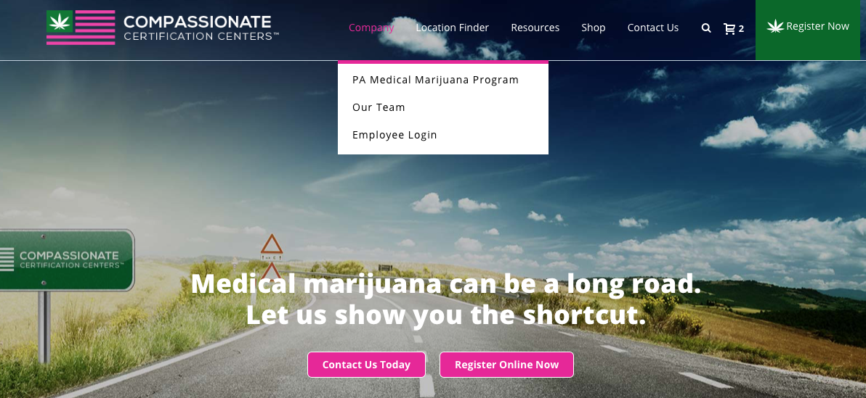

- Enter in your username and password. Each office location has their own login.
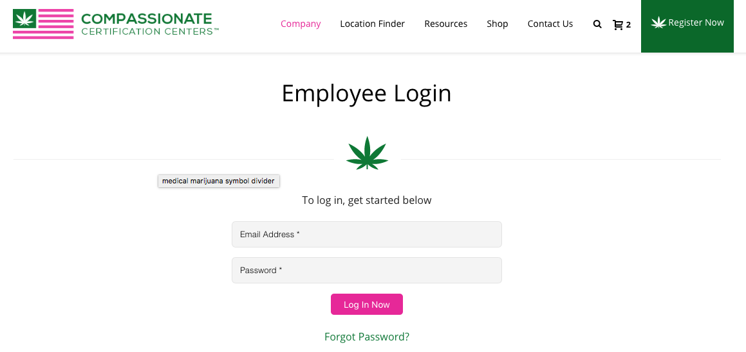

- You are now logged in. You can search for our documents two different ways either by clicking on the certain state on the right-hand side under the “Search by State” or searching by category under the “Search by Category” area. Click on either the category or state you would like to find documents in.

- *Note - You will only be using PA state documents.

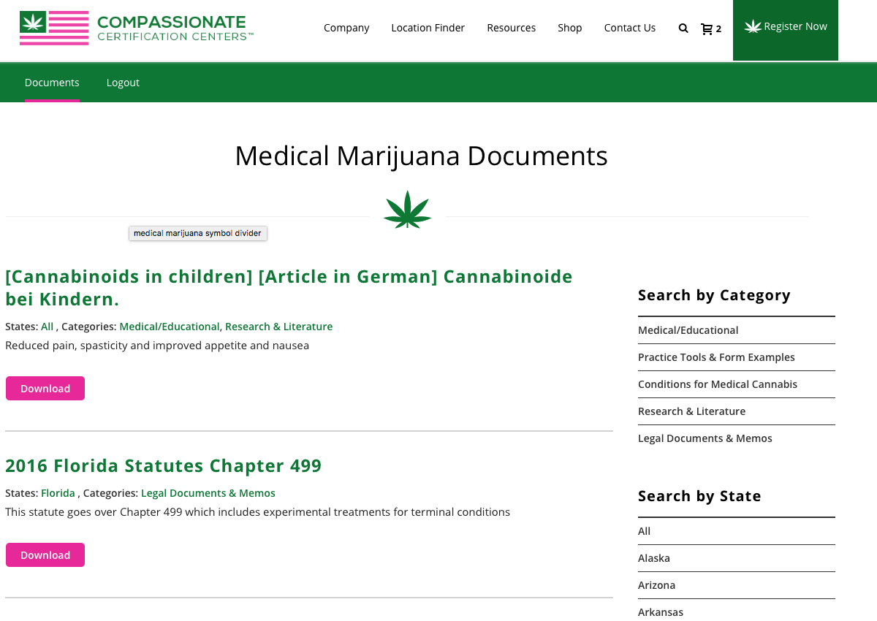

- Our company Portal will pertain company information and many other helpful handouts, websites, instructions, etc. If you ever have a question regarding the company portal, please contact Brittney or Megan.

How to utilize our website information:

- You can visit our website at www.compassionatecertificationcenters.com
- Here we have tons of helpful information regarding the PA MMJ program for patients and caregivers.
- You can visit our FAQ page at https://www.compassionatecertificationcenters.com/faqs/ for answers to most common questions we receive.

Below is a list of the services/pricing that we offer to medical marijuana patients in Pennsylvania:
- $199 Medical Marijuana Card Visit (we accept all major credit cards or cash)
- $75 Physician Medical CBD Consultation
- $50 Registered Nurse Consultations CBD
- $75 Follow up in person visits if requested
- $125 Yearly renewal fee for the card

- Our website also has a resources tab where you can find all our media such as Press Releases, Videos, Podcasts, News Articles, etc.

Knalysis CCC App Information:

We will have a wellness tracker app available for our patients to download from the Apple and Google play store. Please see the attachment below this will be handed out to our patients when they leave their appointment. This provides them with further instructions. This handout will be available in the company portal.

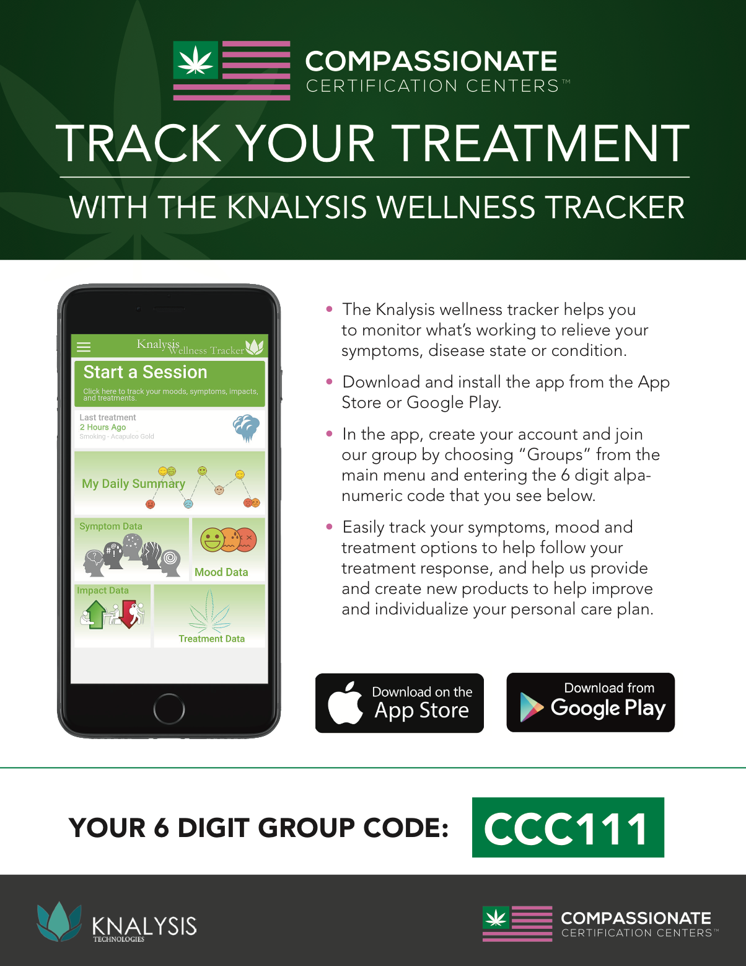

CBD Store Information

- We are licensed distributors for CBD products. We will have CBD products available for purchase in our select office locations and on our website.

- If you have a patient who would like to purchase CBD product off our website, please direct them to our website at www.compassionatecertificationcenters.com

- From there they will click on the link “Shop” in the top bar.

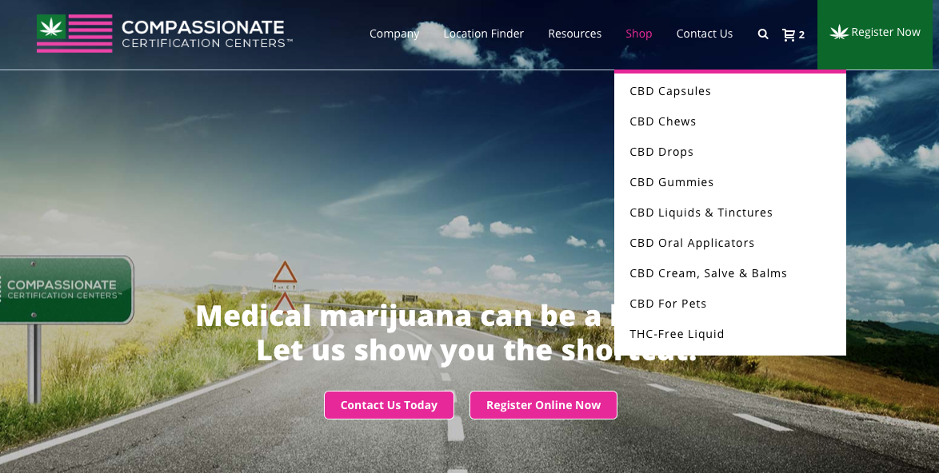

- From there they can put products into their online shopping cart and proceed to checkout. Any online orders we receive are sent to our orders@compassionatecertificationcenters.com email.

- We have a discount code available for return customers. That code is CBD20. They will receive 20% off their order. Please don’t give this code out to everyone, only when they are a return customer.

- Valerie ships our orders for now until this is taken over by a third-party vendor.

CBD Information & Guideline Materials

**These materials are available in our company portal**

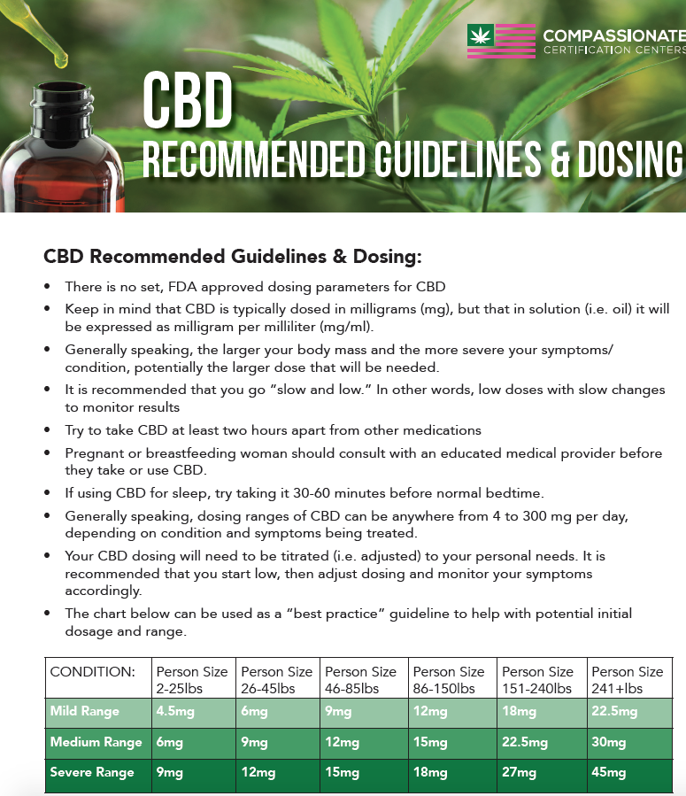

CCC Company Organizational Chart:

This chart is available in our company portal. Please refer to this chart when you are unsure of the correct staff member to contact regarding an issue in a certain department.

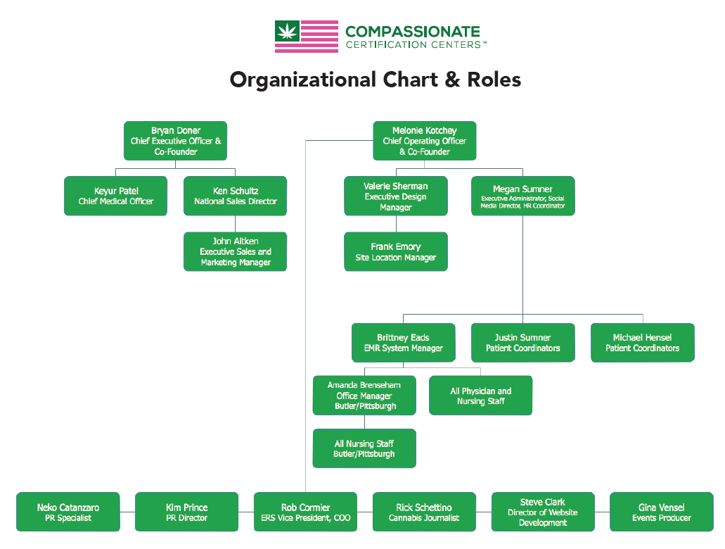

CCC Company Contact List

Please refer to our company contact list located in the company portal for specific employee contact information.

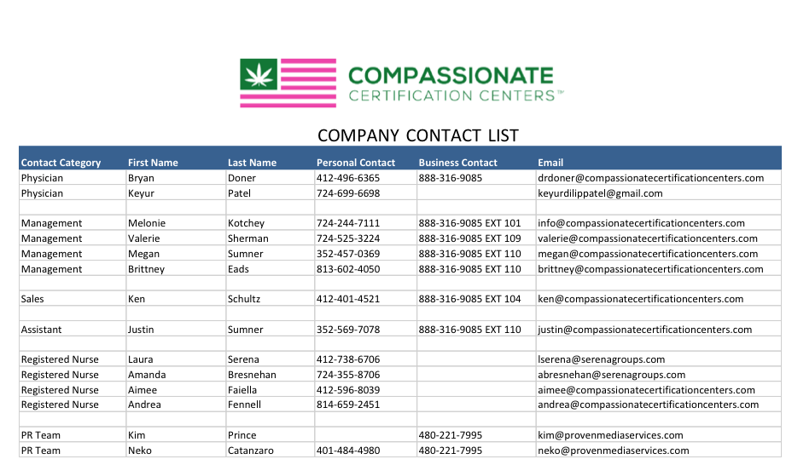

Patient Handout Paperwork

Each office should have the following paper work printed to be able to hand out to patients when they leave their appointments:

- CBD Recommended Dosing Guildelines
- Follow-up appointment cards
- HIPPA Authorization for release of medical information
- What we do brochure
- Knalysis-CCC App Flyer
- Recommended Safe MMJ Use Handout

**An office staff member will be chosen to keep track of these materials.

**If you start running low on any of these materials please get in touch with Valerie – Valerie@compassionatecertificationcenters.com so she can place an order for more.

